

**Name –Sumyak Jain**

**Roll. No – R171218106**

**SAP ID – 500068360**

**DevOps Batch-2 (6th Semester)**

**Test Automation File**

EXPERIMENT-1

Design and document test scenarios for any ecommerce web application to validate

**ecommerce web application - Amazon.in**

**modules-**

* **Registration**
* **Login**
* **Search**
* **validate**

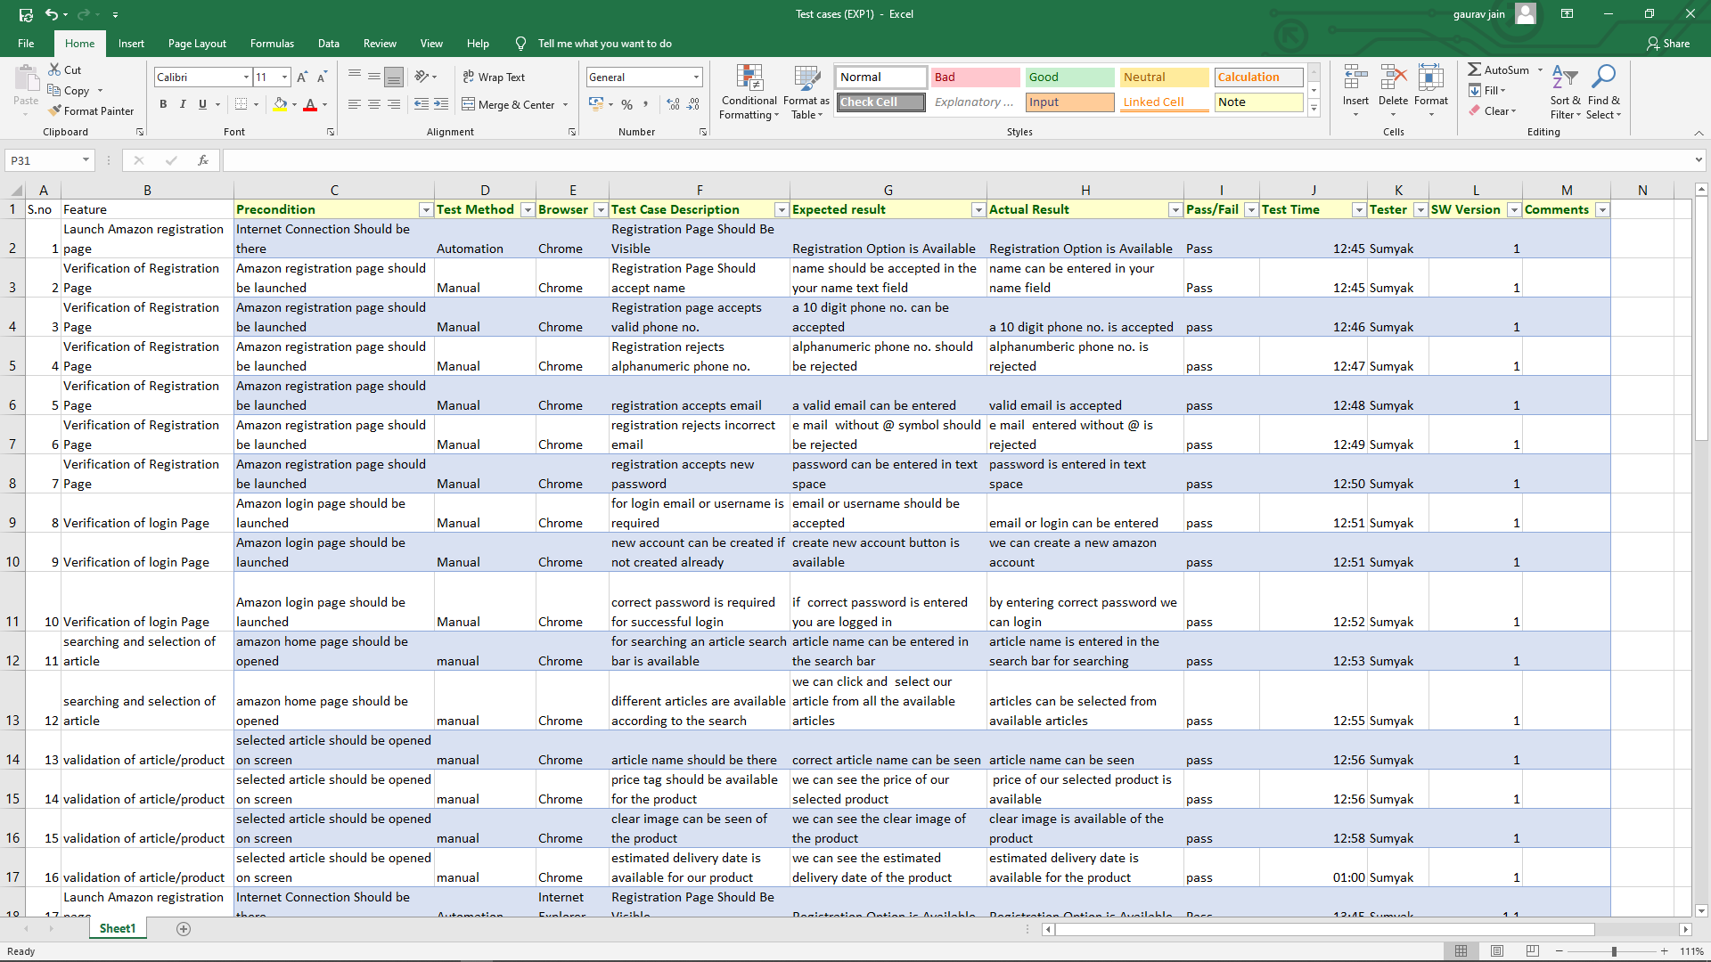

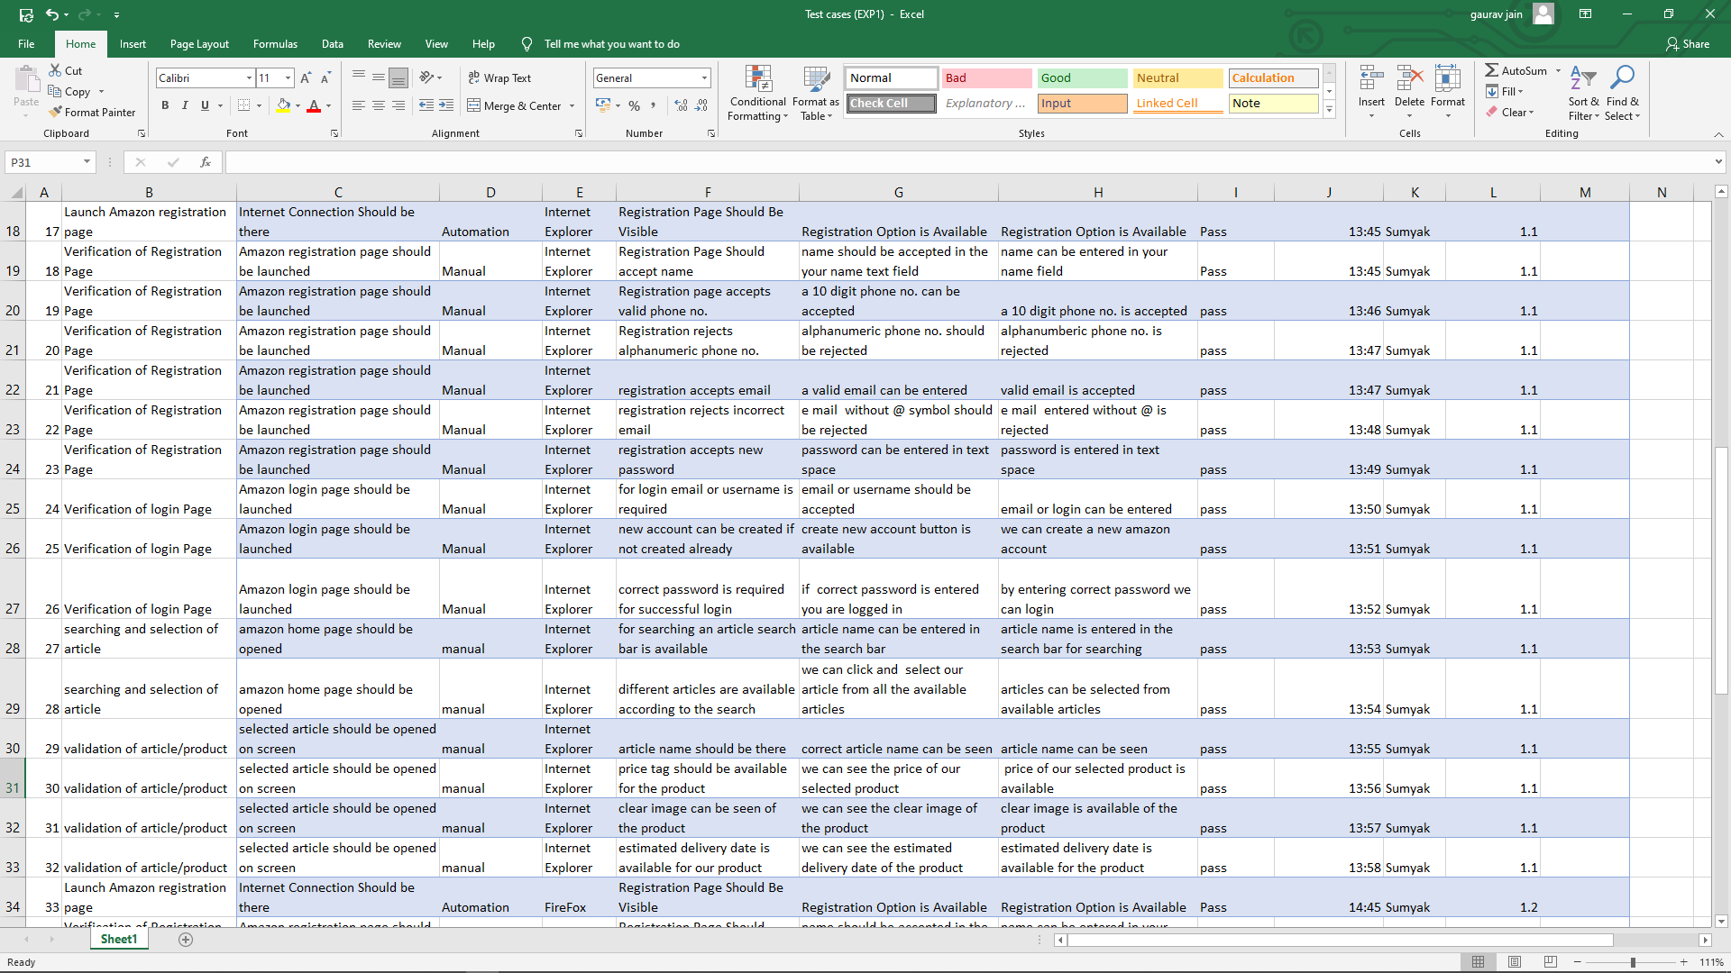

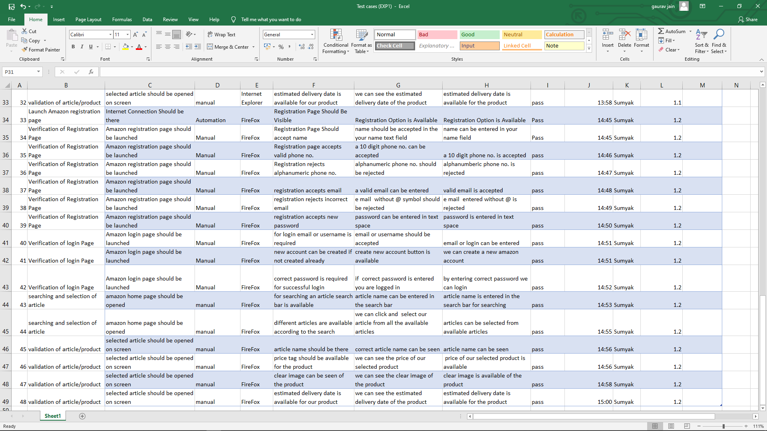

EXPERIMENT-2

*Title:* ***Build an automation script for registration and login for e-commerce platform.***

***Content:***

* ***Write the automation script for the login at amazon e-commerce web-site.***
* ***Write the automation script for the registration at amazon e-commerce web-site.***
* ***Write the automation script for searching a product (using xpath) at amazon e-commerce web-site.***
* **Register to amazon.in**

**CODE//**

import org.openqa.selenium.By;  
import org.openqa.selenium.JavascriptExecutor;  
import org.openqa.selenium.WebDriver;  
import org.openqa.selenium.WebElement;  
import org.openqa.selenium.chrome.ChromeDriver;  
  
public class registration {  
  
 public static void main(String[] args) {  
  
 // System Property for Chrome Driver  
 System.*setProperty*("webdriver.chrome.driver", "D:\\ChromeDriver\\chromedriver.exe");  
 WebDriver driver=new ChromeDriver();  
 // Launch Website  
 driver.manage().window().maximize();  
 System.*out*.println("1");  
 driver.get("https://www.amazon.in/ap/register?showRememberMe=true&openid.pape.max_auth_age=0&openid.return_to=https%3A%2F%2Fwww.amazon.in%2F%3Fref_%3Dnav_ya_signin&prevRID=5H4R427ZZ7HKP7CZASCH&openid.identity=http%3A%2F%2Fspecs.openid.net%2Fauth%2F2.0%2Fidentifier_select&openid.assoc_handle=inflex&openid.mode=checkid_setup&prepopulatedLoginId=&failedSignInCount=0&openid.claimed_id=http%3A%2F%2Fspecs.openid.net%2Fauth%2F2.0%2Fidentifier_select&pageId=inflex&openid.ns=http%3A%2F%2Fspecs.openid.net%2Fauth%2F2.0");  
 driver.manage().window().maximize();  
 driver.findElement(By.*id*("ap_customer_name")).sendKeys("");  
 driver.findElement(By.*id*("ap_phone_number")).sendKeys("");  
 driver.findElement(By.*id*("ap_password")).sendKeys("");  
 driver.findElement(By.*className*("a-button-input")).click();  
   
 }  
  
}

**OUTPUT**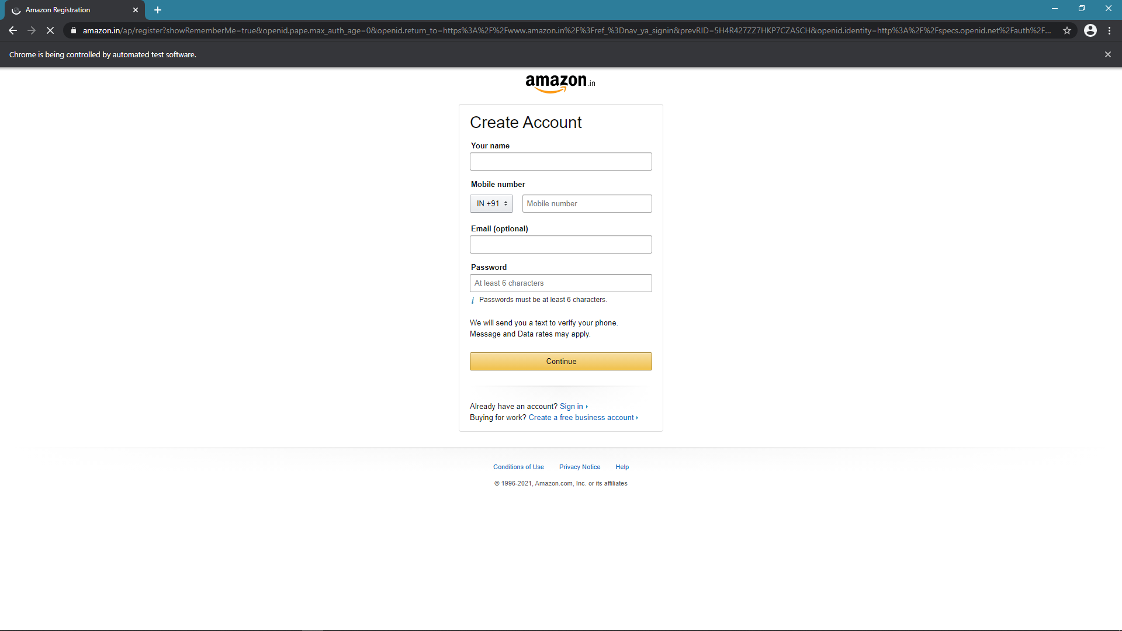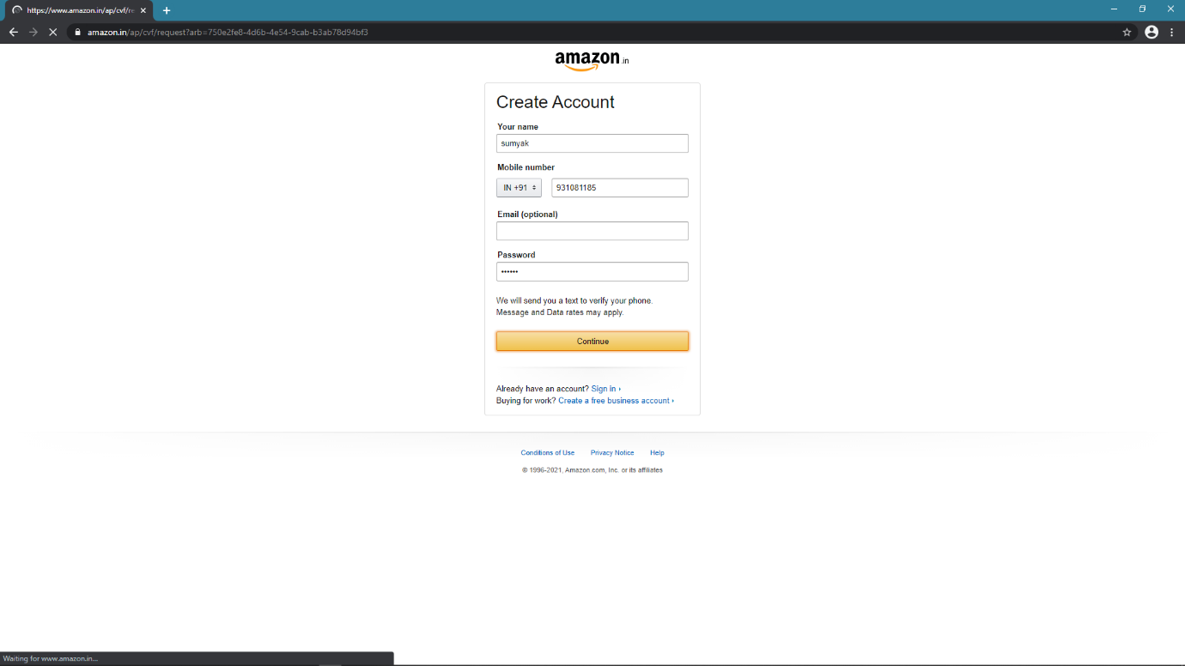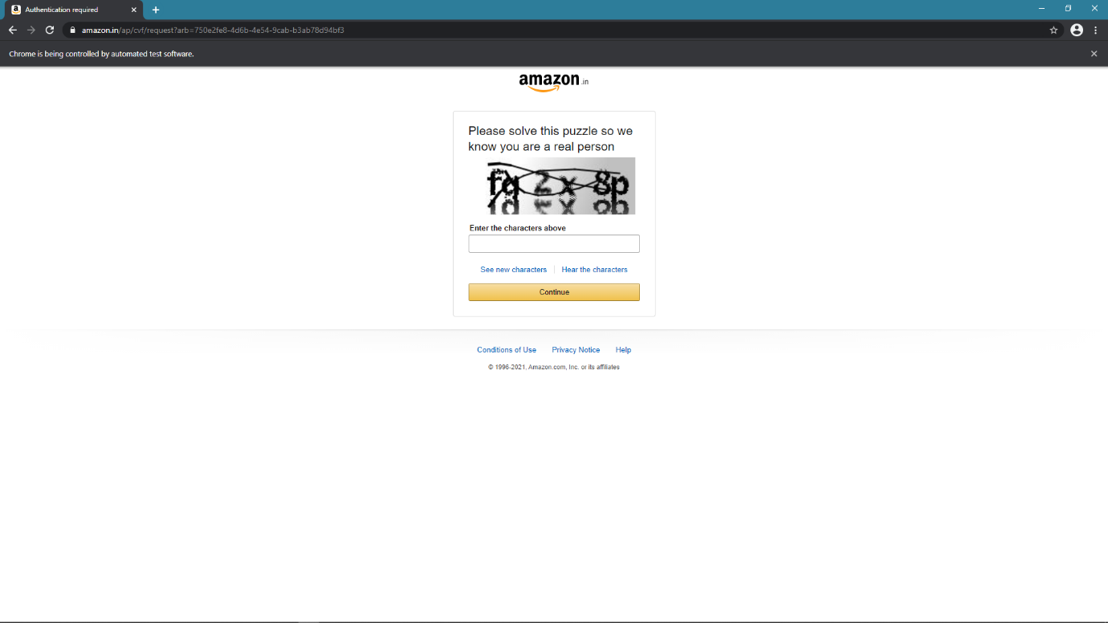

* **Login to amazon.in**

**CODE//**

import org.openqa.selenium.By;  
import org.openqa.selenium.JavascriptExecutor;  
import org.openqa.selenium.WebDriver;  
import org.openqa.selenium.WebElement;  
import org.openqa.selenium.chrome.ChromeDriver;  
  
public class demo1 {  
  
 public static void main(String[] args) {  
  
 // System Property for Chrome Driver  
 System.*setProperty*("webdriver.chrome.driver", "D:\\ChromeDriver\\chromedriver.exe");  
 WebDriver driver=new ChromeDriver();  
 // Launch Website  
 driver.navigate().to("https://www.amazon.in/");  
 driver.manage().window().maximize();  
 System.*out*.println("1");  
 WebElement signin = driver.findElement(By.*id*("nav-link-accountList-nav-line-1"));  
 signin.click();  
 System.*out*.println("2");  
 WebElement email = driver.findElement(By.*id*("ap_email"));  
 email.sendKeys("***********");  
 System.*out*.println("3");  
 WebElement continu = driver.findElement(By.*id*("continue"));  
 continu.click();  
 System.*out*.println("4");  
 WebElement pswd = driver.findElement(By.*id*("ap_password"));  
 pswd.sendKeys("******");  
 System.*out*.println("5");  
 WebElement signin1 = driver.findElement(By.*id*("signInSubmit"));  
 signin1.click();  
 System.*out*.println("6");  
   
 }  
}

**OUTPUT**

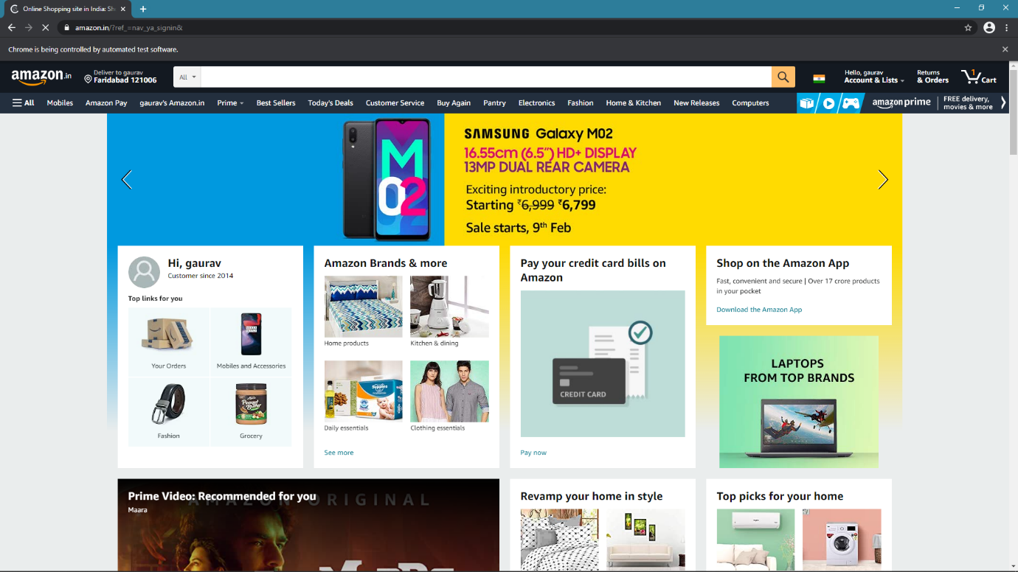

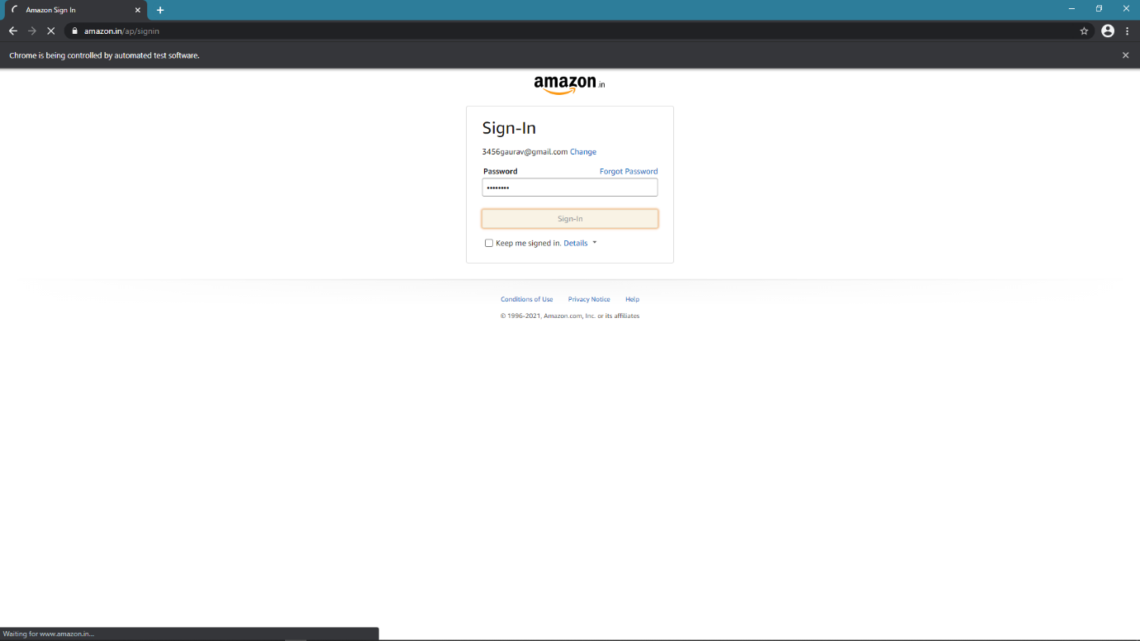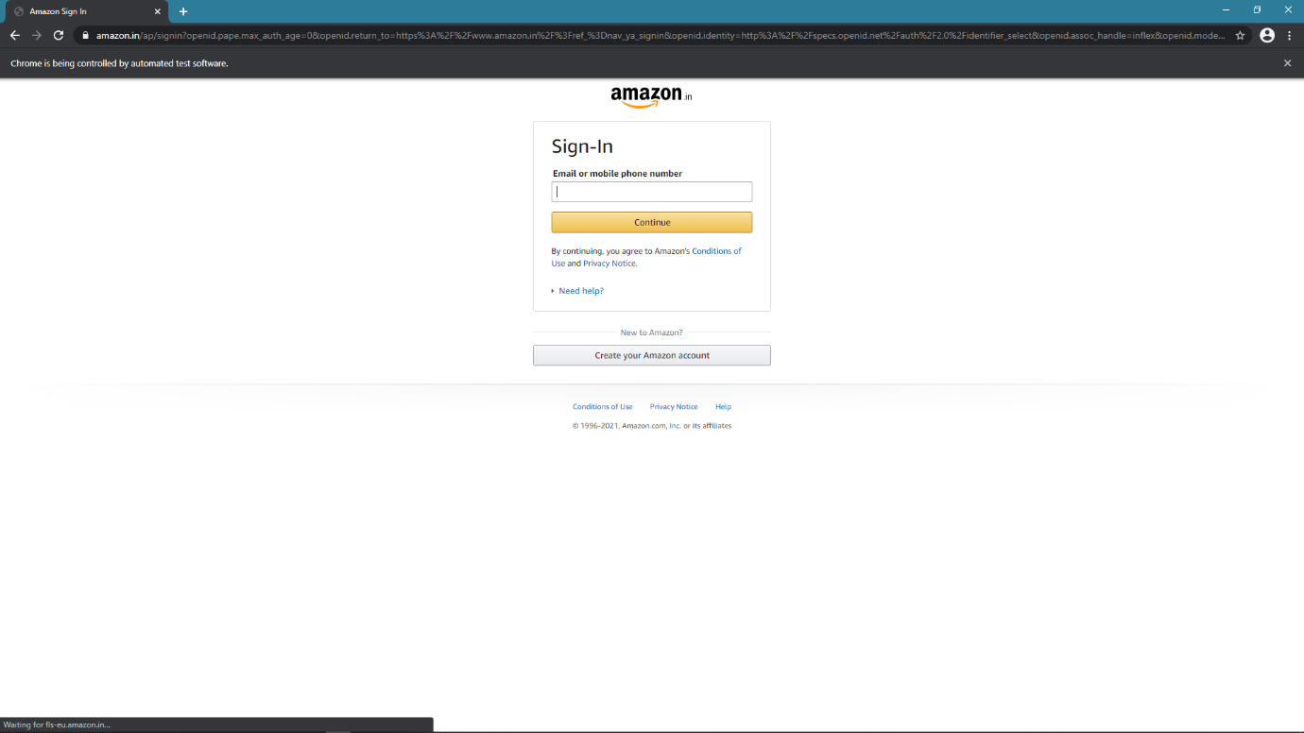

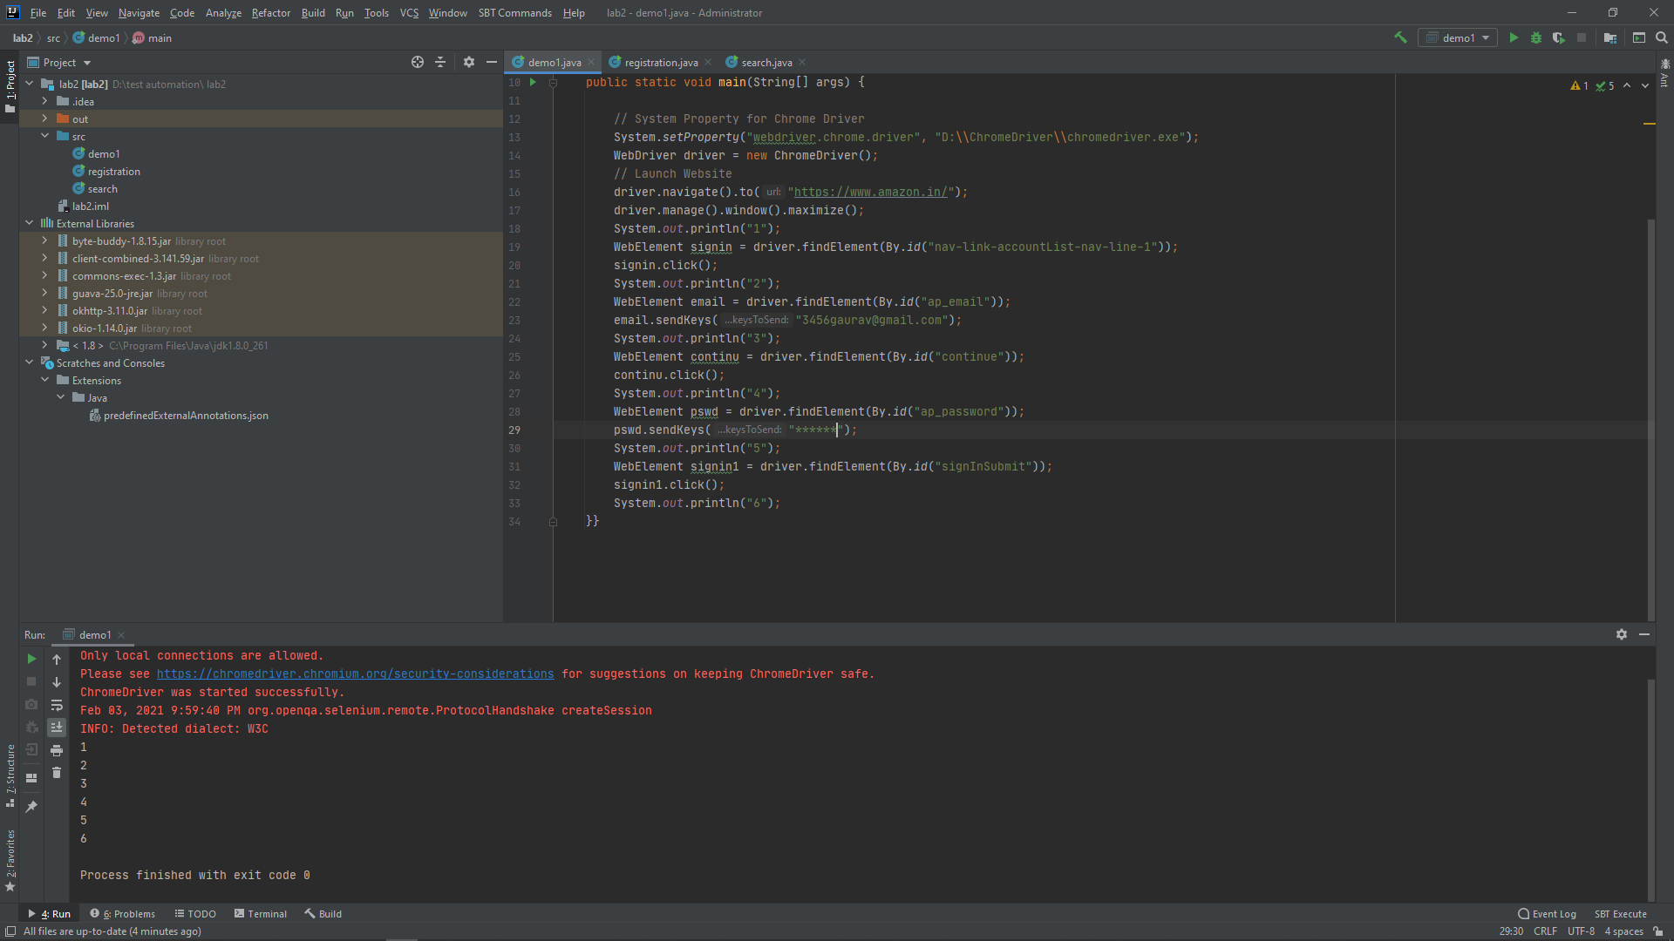

* **Search product and validate**

**CODE//**

import org.openqa.selenium.By;  
import org.openqa.selenium.JavascriptExecutor;  
import org.openqa.selenium.WebDriver;  
import org.openqa.selenium.WebElement;  
import org.openqa.selenium.chrome.ChromeDriver;  
  
public class search {  
 public static void main(String[] args){  
 // System Property for Chrome Driver  
 System.*setProperty*("webdriver.chrome.driver", "D:\\ChromeDriver\\chromedriver.exe");  
  
 WebDriver driver=new ChromeDriver();  
  
 // Launch Website  
 driver.navigate().to("https://www.amazon.in/");  
 driver.manage().window().maximize();  
 System.*out*.println("1");  
  
 WebElement search = driver.findElement(By.*xpath*("/html/body/div[1]/header/div/div[1]/div[2]/div/form/div[2]/div[1]/input"));  
 search.sendKeys("oneplus 8t 12gb ram 256gb mobile aquamarine green");  
 System.*out*.println("2");  
  
 WebElement searchButton = driver.findElement(By.*id*("nav-search-submit-button"));  
 searchButton.click();  
 System.*out*.println("3");  
  
 WebElement name = driver.findElement(By.*xpath*("//*[@id=\"search\"]/div[1]/div[2]/div/span[3]/div[2]/div[1]/div/span/div/div/div[2]/div[2]/div/div[1]/div/div/div[1]/h2/a/span"));  
 name.click();  
 System.*out*.println("4");  
  
 WebElement image = driver.findElement(By.*xpath*("/html/body/div[1]/div[2]/div[1]/div[2]/div/span[3]/div[2]/div[1]/div/span/div/div/div[2]/div[1]/div/div/span/a/div/img"));  
 image.isDisplayed();  
 System.*out*.println("image is displayed");  
  
 WebElement price = driver.findElement(By.*xpath*("/html/body/div[1]/div[2]/div[1]/div[2]/div/span[3]/div[2]/div[1]/div/span/div/div/div[2]/div[2]/div/div[2]/div[1]/div/div[1]/div[1]/div/div/a/span/span[2]/span[2]"));  
 price.isDisplayed();  
 System.*out*.println("price is there");  
 }  
}

**OUTPUT**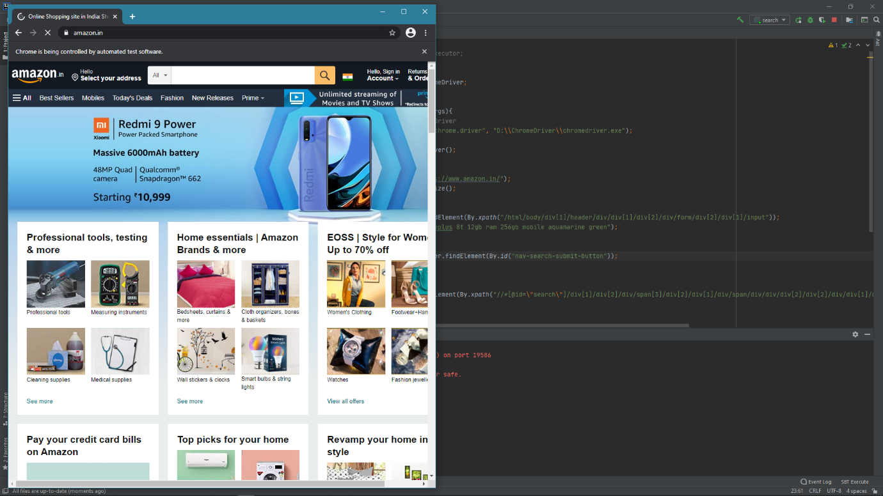

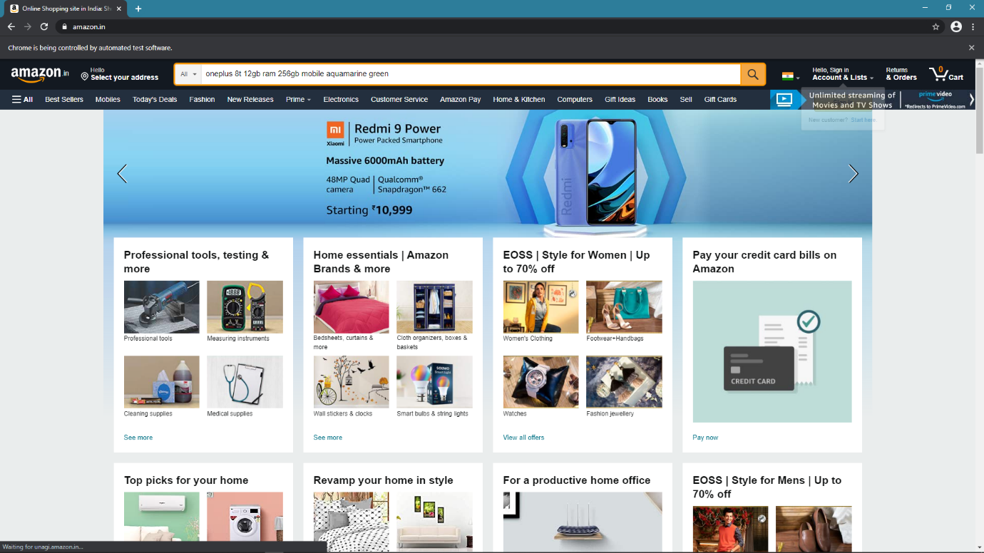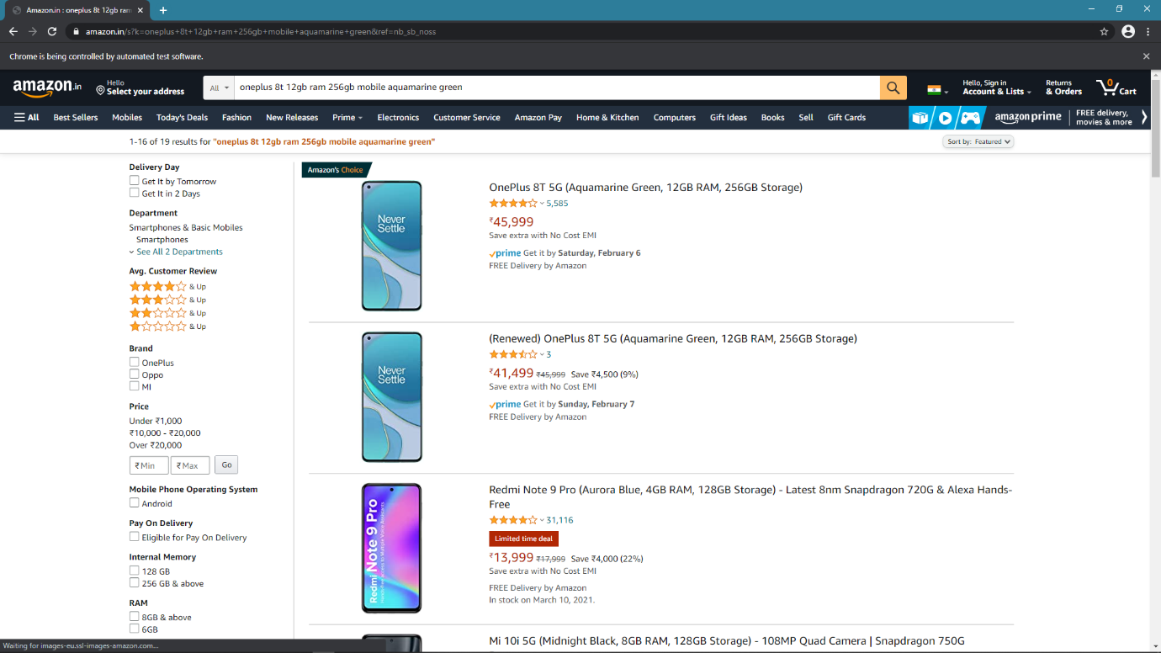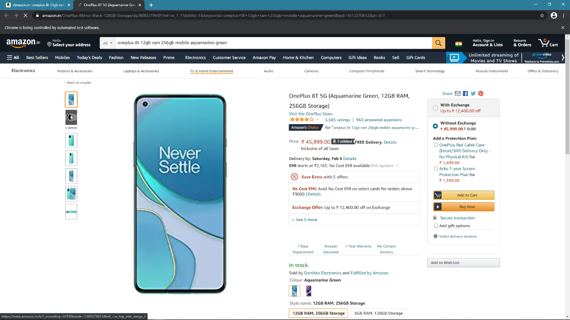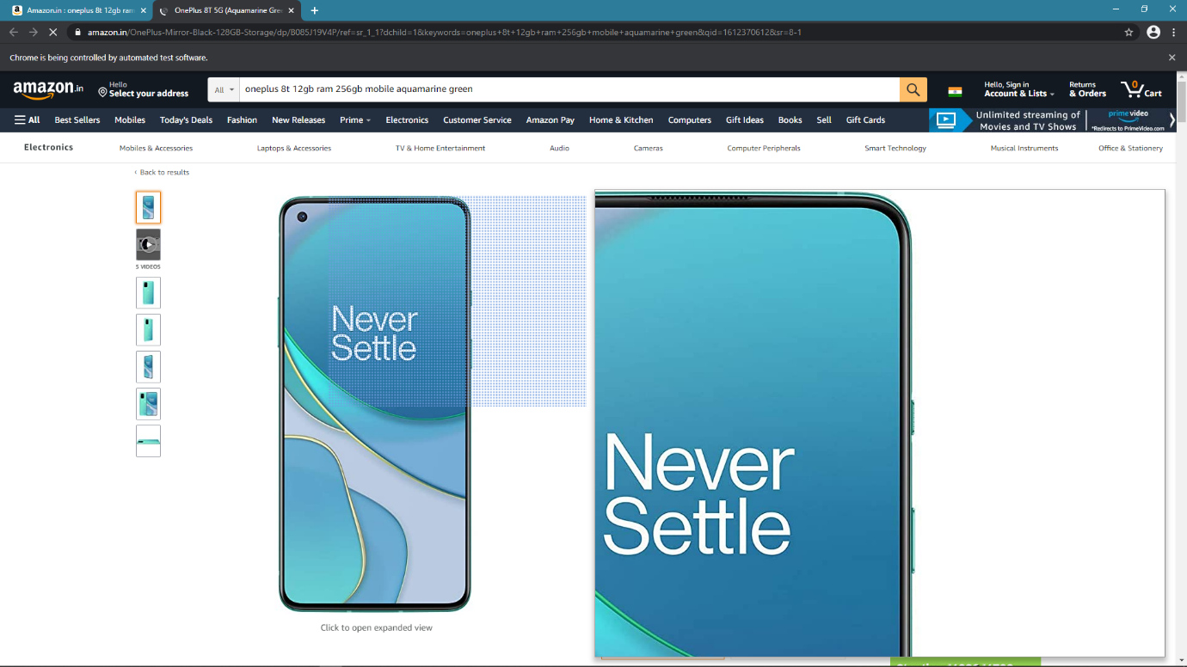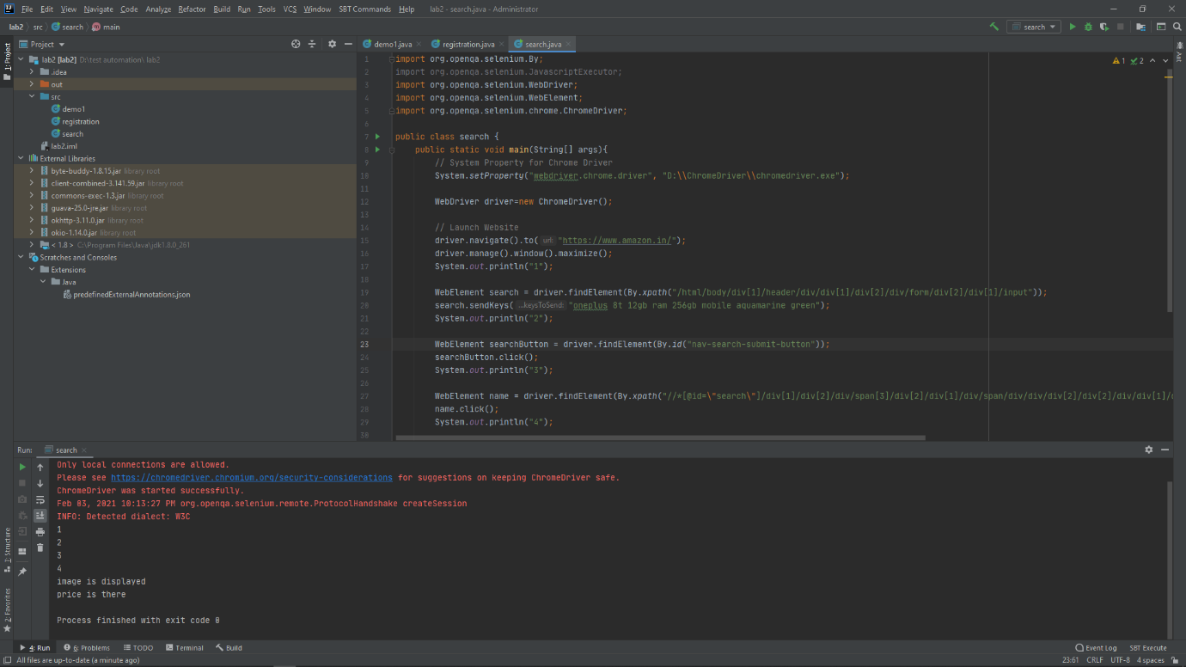

EXPERIMENT-3

*Title:* ***Build an automation script for searching the article and validate the searching of the article***

***Content:*** ***Build an automation script for searching the article and validate the searching of the article --***

* ***Proceed to write the script for searching the article on the top of previous script when the user is successfully***
* ***Use the same strategy as done in Lab1, Lab2 along with proper assertions to validate the searching of an article***

**Search and validate product at amazon.in**

**Code**

import org.openqa.selenium.By;  
import org.openqa.selenium.JavascriptExecutor;  
import org.openqa.selenium.WebDriver;  
import org.openqa.selenium.WebElement;  
import org.openqa.selenium.chrome.ChromeDriver;  
  
import java.util.ArrayList;  
  
public class search {  
 public static void main(String[] args){  
 // System Property for Chrome Driver  
 System.*setProperty*("webdriver.chrome.driver", "D:\\ChromeDriver\\chromedriver.exe");  
  
 WebDriver driver=new ChromeDriver();  
  
 // Launch Website  
 driver.navigate().to("https://www.amazon.in/");  
 driver.manage().window().maximize();  
 System.*out*.println("1");  
  
 WebElement search = driver.findElement(By.*xpath*("/html/body/div[1]/header/div/div[1]/div[2]/div/form/div[2]/div[1]/input"));  
 search.sendKeys("oneplus 8t 12gb ram 256gb mobile aquamarine green");  
 System.*out*.println("2");  
  
 WebElement searchButton = driver.findElement(By.*id*("nav-search-submit-button"));  
 searchButton.click();  
 System.*out*.println("3");  
  
  
 WebElement image = driver.findElement(By.*xpath*("//*[@id=\"search\"]/div[1]/div[2]/div/span[3]/div[2]/div[2]/div/span/div/div/div[2]/div[1]/div/div/span/a/div/img"));  
 image.isDisplayed();  
 System.*out*.println("image is displayed");  
  
 WebElement price = driver.findElement(By.*xpath*("//*[@id=\"search\"]/div[1]/div[2]/div/span[3]/div[2]/div[2]/div/span/div/div/div[2]/div[2]/div/div[2]/div[1]/div/div[1]/div[1]/div/div/a/span/span[2]/span[1]"));  
 price.isDisplayed();  
 System.*out*.println("price is there");  
  
 WebElement name = driver.findElement(By.*xpath*("//*[@id=\"search\"]/div[1]/div[2]/div/span[3]/div[2]/div[2]/div/span/div/div/div[2]/div[2]/div/div[1]/div/div/div[1]/h2/a/span"));  
 name.click();  
 System.*out*.println("4");  
  
 ArrayList<String> noOftabs= new ArrayList<String>(driver.getWindowHandles());  
 driver.switchTo().window(noOftabs.get(1));  
 System.*out*.println("tabs are"+ noOftabs);  
  
 WebElement buy_now = driver.findElement(By.*id*("buy-now-button"));  
 buy_now.isDisplayed();  
 System.*out*.println("buy now is there");  
  
 WebElement days = driver.findElement(By.*xpath*("//*[@id=\"icon-farm-container\"]/div/div[1]/span/div[1]/img"));  
 days.isDisplayed();  
 System.*out*.println("7 Days Replacement logo is there");  
  
 }  
}

**Output**

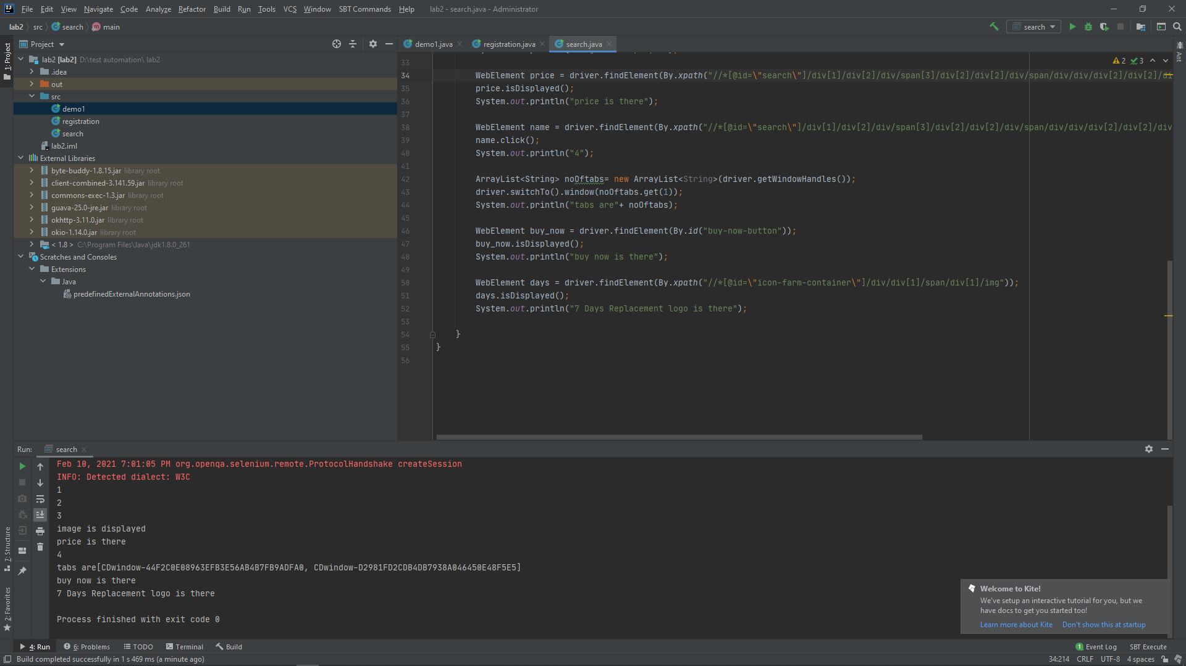

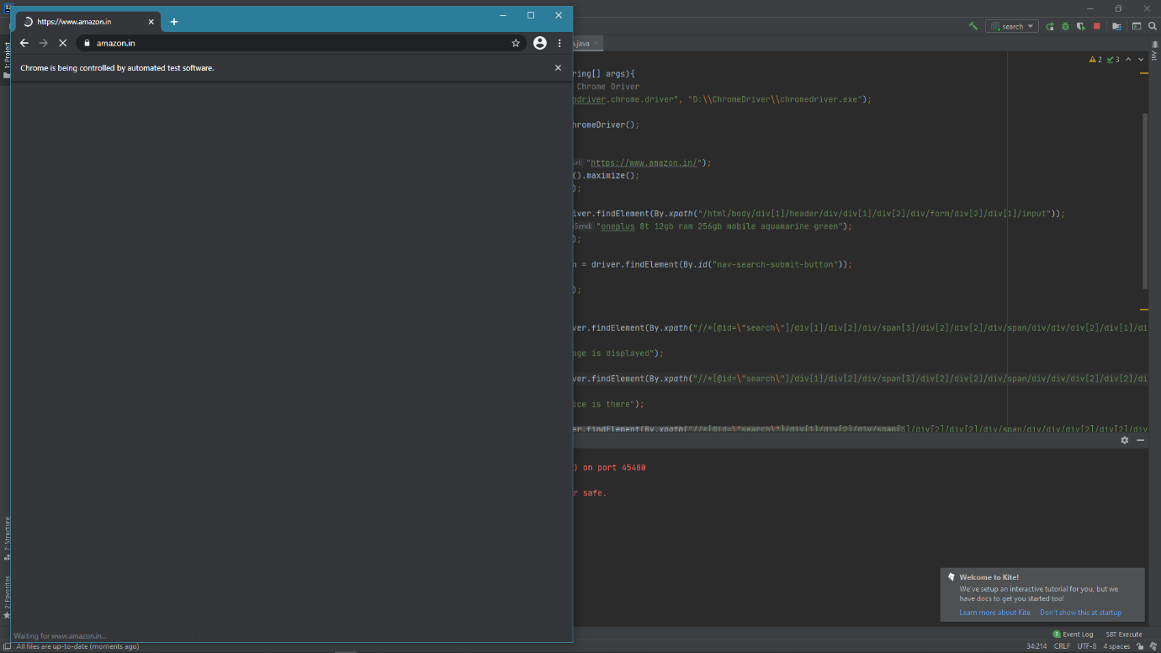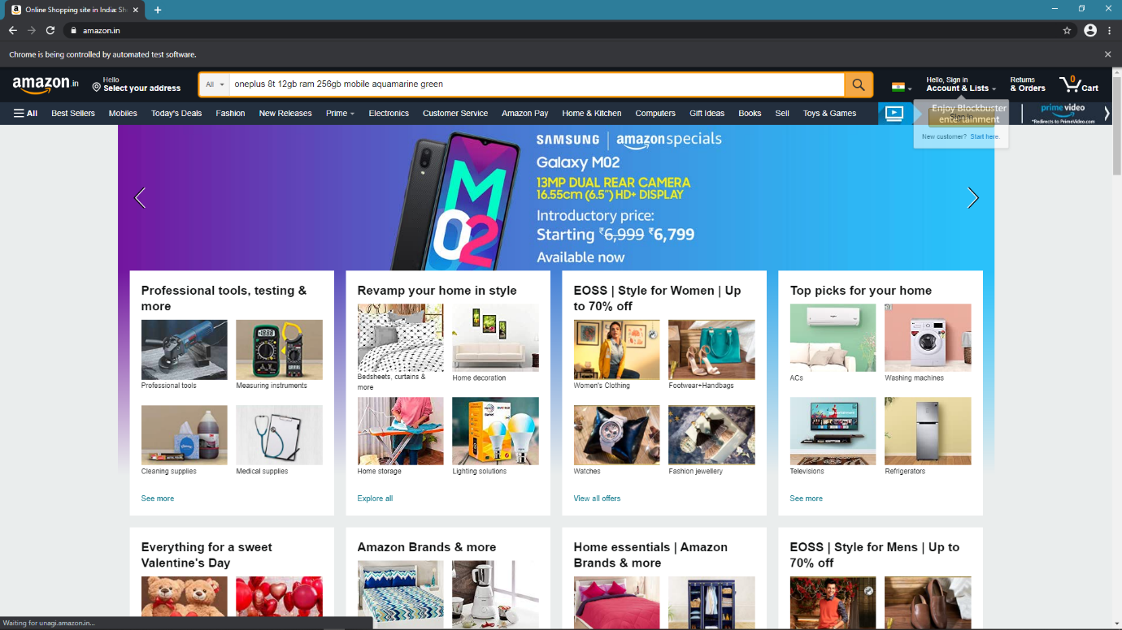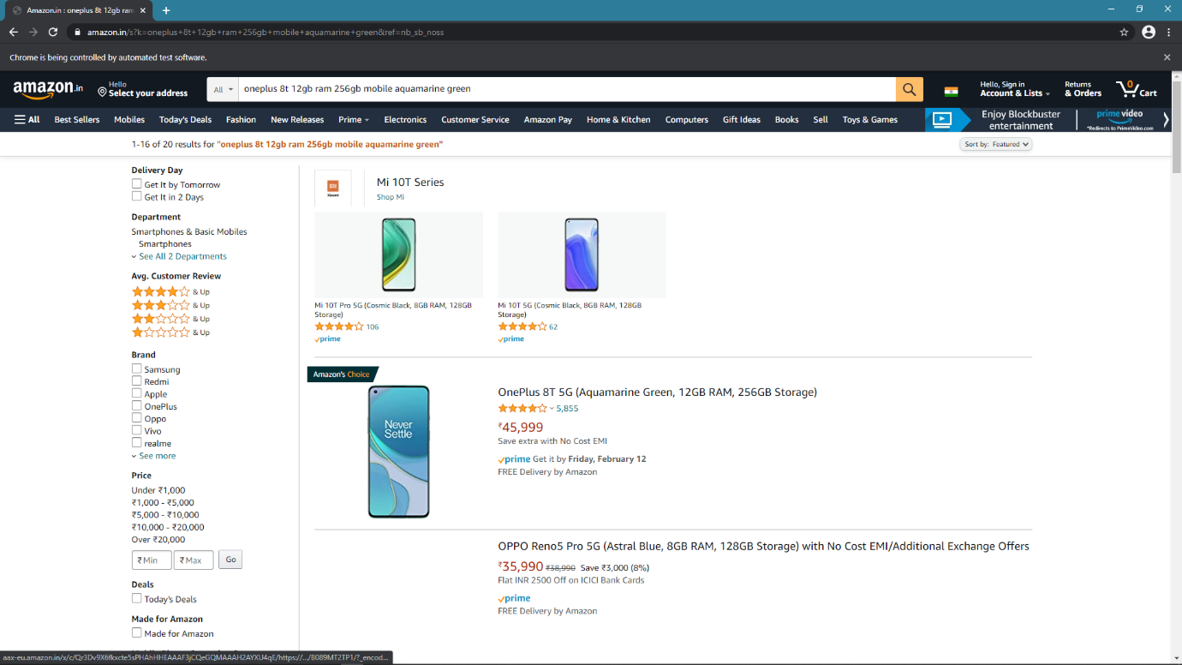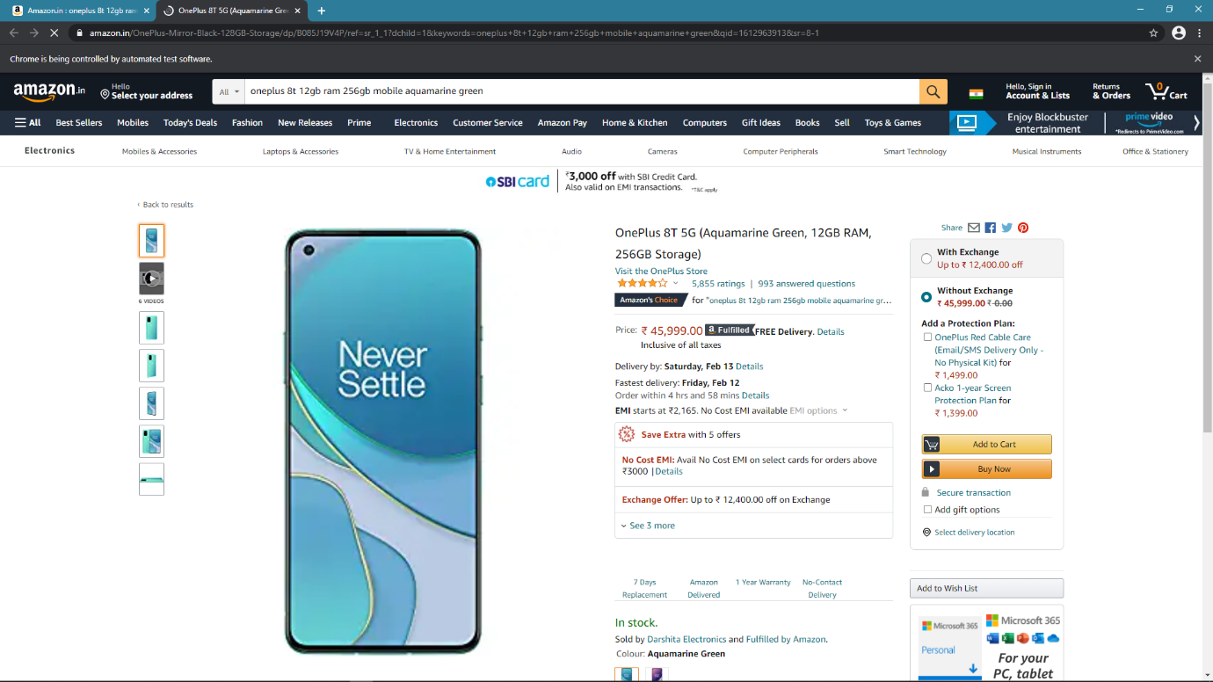

**EXPERIMENT-4**

*Title:* ***Build an automation script for navigating to the article details page and validate all.***

***Content:*** ***Build an automation script for navigating to the article details page and validate all the details for an article Proceed to article details page, use the same strategy as done in lab1,lab2 to build the script and after successfully validating the search and use assertion at field level to validate them correctly***

**CODE**

import org.openqa.selenium.By;  
import org.openqa.selenium.WebDriver;  
import org.openqa.selenium.WebElement;  
import org.openqa.selenium.chrome.ChromeDriver;  
import static org.testng.Assert.*assertEquals*;  
import static org.testng.Assert.*assertTrue*;  
import static org.testng.Assert.*assertNotNull*;  
import java.util.ArrayList;  
import java.util.Set;  
public class assertion {  
 public static void main(String[] args){  
 // System Property for Chrome Driver  
 System.*setProperty*("webdriver.chrome.driver", "D:\\ChromeDriver\\chromedriver.exe");  
  
 WebDriver driver=new ChromeDriver();  
  
 // Launch Website  
 driver.navigate().to("https://www.amazon.in/");  
 driver.manage().window().maximize();  
 System.*out*.println("1");  
  
 WebElement search = driver.findElement(By.*xpath*("/html/body/div[1]/header/div/div[1]/div[2]/div/form/div[2]/div[1]/input"));  
 search.sendKeys("Samsung Galaxy M51 (Electric Blue, 6GB RAM, 128GB Storage)");  
 System.*out*.println("2");  
  
 WebElement searchButton = driver.findElement(By.*id*("nav-search-submit-button"));  
 searchButton.click();  
 System.*out*.println("3");  
  
  
 WebElement name = driver.findElement(By.*xpath*("//*[@id=\"search\"]/div[1]/div[2]/div/span[3]/div[2]/div[4]/div/span/div/div/div[2]/div[2]/div/div[1]/div/div/div[1]/h2/a/span"));  
 name.click();  
 System.*out*.println("4");  
  
 Set<String> listOfTabs = driver.getWindowHandles();  
  
 ArrayList<String> arr = new ArrayList<String>(listOfTabs);  
  
 driver.switchTo().window(arr.get(1));  
  
 System.*out*.println("\nIn another window\n");  
  
 WebElement mobileDescription = driver.findElement(By.*id*("productTitle"));  
 System.*out*.println("Product tittle is there");  
  
 String check=mobileDescription.getText();  
 System.*out*.println("check "+ check);  
 *assertEquals*("Samsung Galaxy M51 (Electric Blue, 6GB RAM, 128GB Storage)",check);  
 System.*out*.println("Product tittle is correct (assert equals)");  
  
 *assertTrue*(check.contentEquals(check));  
 System.*out*.println("assert true");  
 *assertNotNull*(check);  
 System.*out*.println("assert not null");  
  
 }  
}

**OUTPUT**

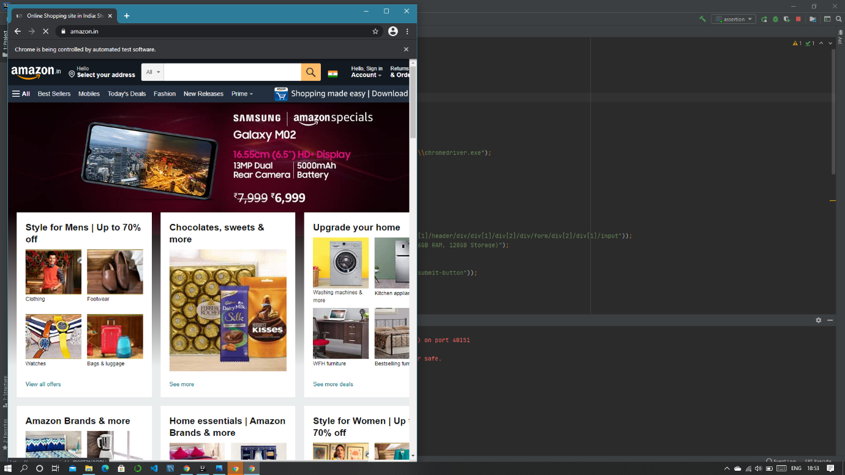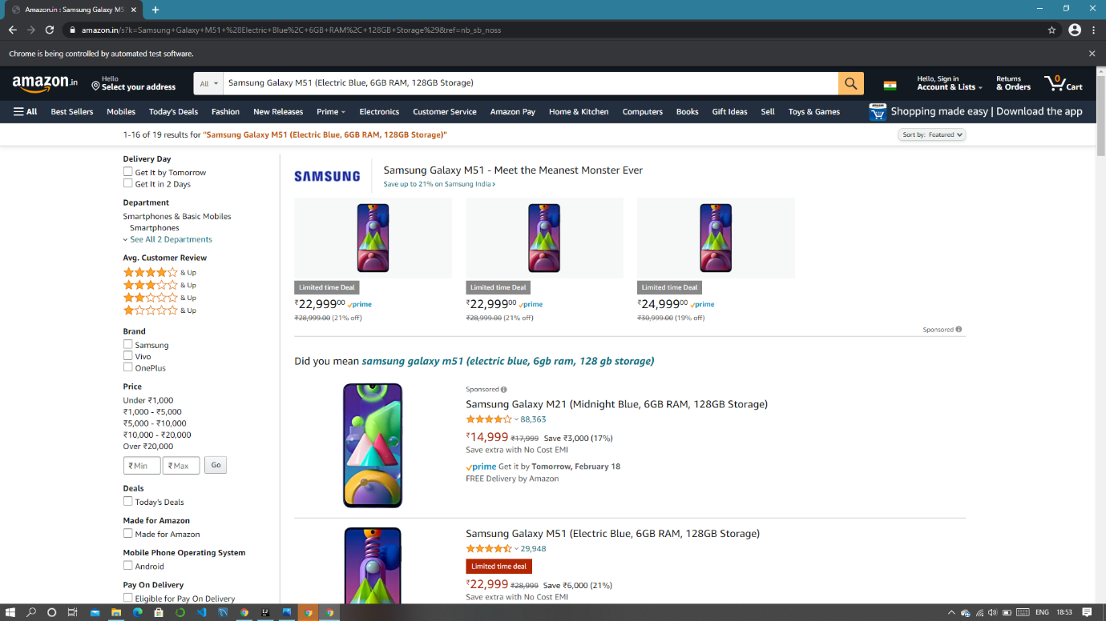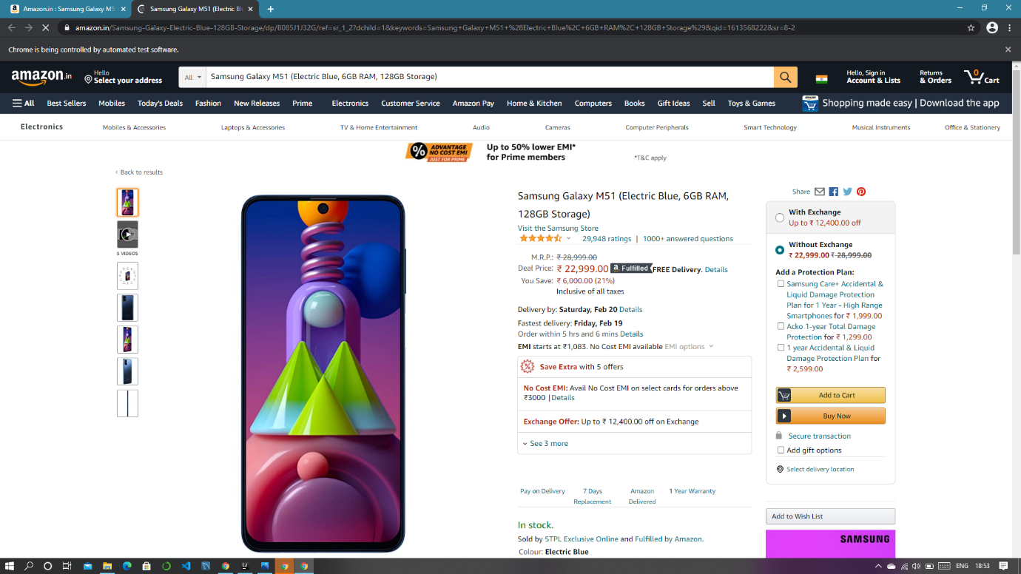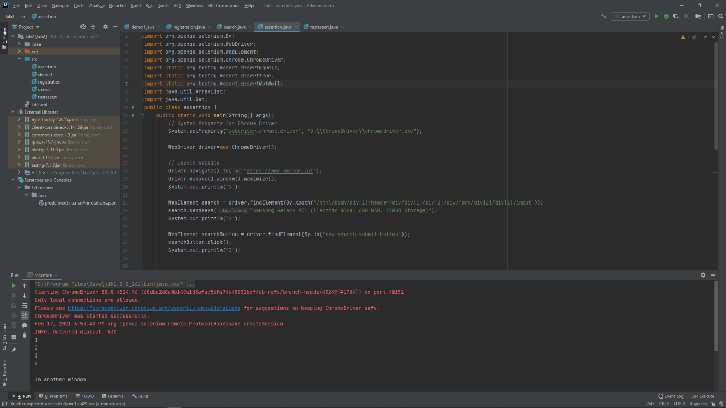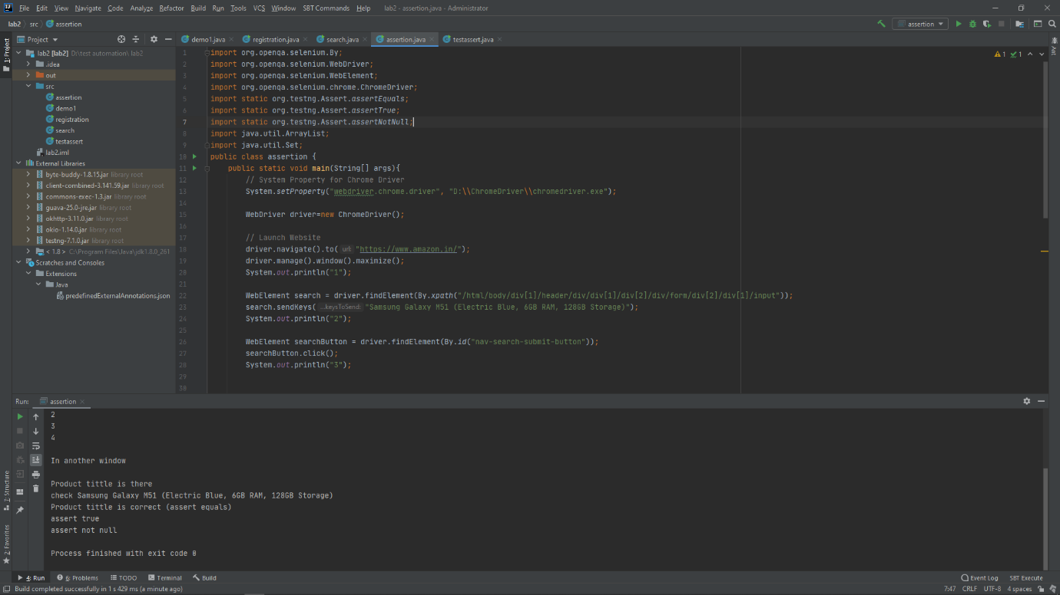

**EXPERIMENT-5**

***Title: Use the data driven test automation framework to parameterize the data.***

***Content:*** ***Use the data driven test automation framework to parameterize the data. Write the test class and create read data method to read the data and use the data provider of TestNG to get the data***

**CODE**

import java.util.ArrayList;  
import java.util.Set;  
import static org.testng.Assert.*;  
import org.openqa.selenium.By;  
import org.openqa.selenium.WebDriver;  
import org.openqa.selenium.WebElement;  
import org.openqa.selenium.chrome.ChromeDriver;  
import org.testng.annotations.*;  
  
public class test_annotation {  
  
 String base_URL = "https://www.amazon.in/";  
 // String driverpath = "webdriver.chrome.driver\", \"D:\\ChromeDriver\\chromedriver.exe";  
 WebDriver chromedriver;  
  
 @BeforeTest  
 public void launchBrowser() {  
 // System.setProperty("webdriver.chrome.driver", driverpath);  
 System.*setProperty*("webdriver.chrome.driver", "D:\\ChromeDriver\\chromedriver.exe");  
 chromedriver = new ChromeDriver();  
 chromedriver.get(base_URL);  
 chromedriver.manage().window().maximize();  
 }  
  
 @Test(priority=0)  
 public void SearchFiled() {  
 WebElement Search_field = chromedriver.findElement(By.*id*("twotabsearchtextbox"));  
 Search_field.sendKeys("oneplus 8t 12gb ram 256gb mobile aquamarine green");  
  
 }  
 @Test(priority=1)  
 public void click_To_SearchButton() {  
 WebElement searchButton = chromedriver.findElement(By.*id*("nav-search-submit-button"));  
 searchButton.click();  
  
 }  
  
 @Test(priority=2)  
 public void click_To_Article() {  
 WebElement Click_on_product = chromedriver.findElement(By.*xpath*("//*[@id=\"search\"]/div[1]/div[2]/div/span[3]/div[2]/div[2]/div/span/div/div/div[2]/div[2]/div/div[1]/div/div/div[1]/h2/a/span"));  
 Click_on_product.click();  
 }  
  
 @Test(priority=3)  
 public void Move_To_AnotherTab() {  
 Set<String> listOfTabs = chromedriver.getWindowHandles();  
 ArrayList<String> arr = new ArrayList<String>(listOfTabs);  
 chromedriver.switchTo().window(arr.get(1));  
  
 System.*out*.println("Move to another window !");  
 }  
  
 @Test(priority=4)  
 public void ValidateArticle() {  
 WebElement Product_Description = chromedriver.findElement(By.*id*("productTitle"));  
 String check = Product_Description.getText();  
 System.*out*.println("check " + check);  
  
 *assertNotNull*(check);  
 System.*out*.println("The Product Description is not null !");  
  
 *assertTrue*(check.contentEquals(check));  
 System.*out*.println("assert true");  
 }  
  
 @AfterTest  
 public void Quite() {  
 chromedriver.quit();  
 }  
}

**OUTPUT**

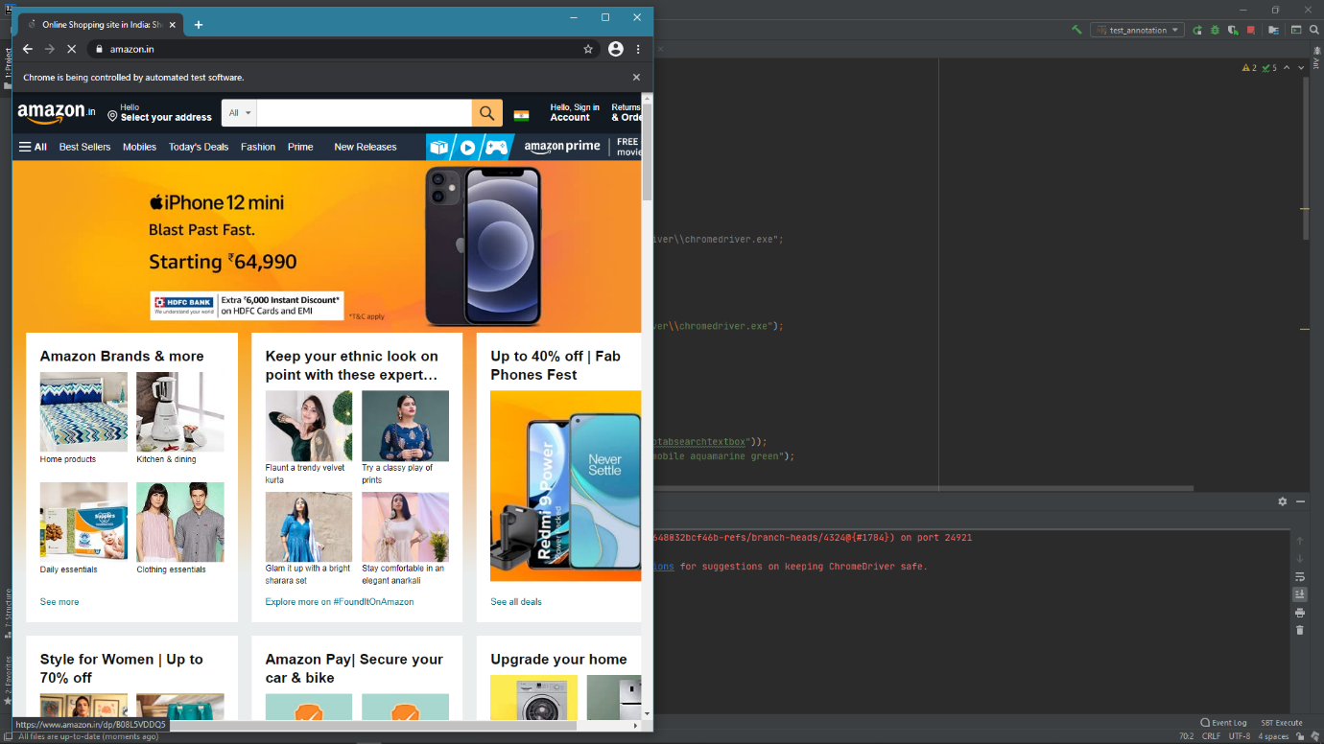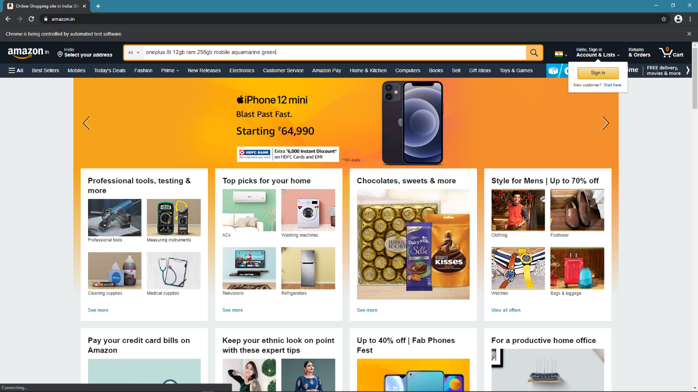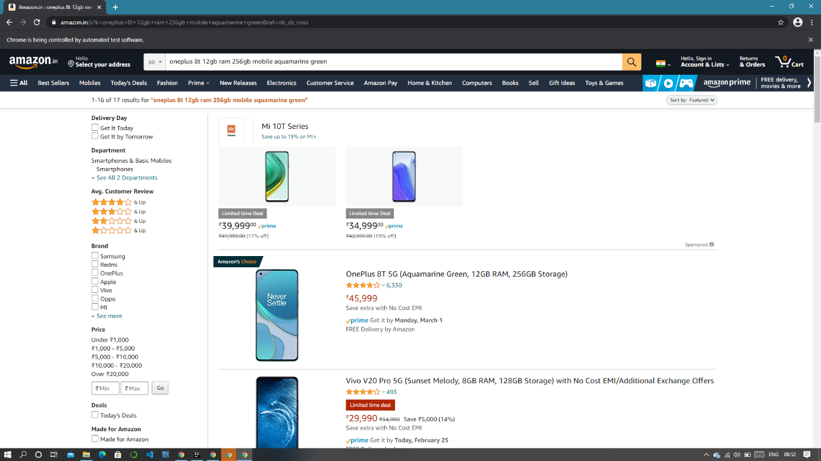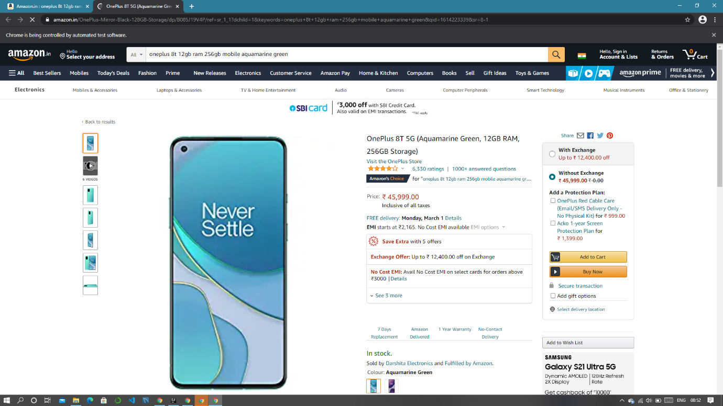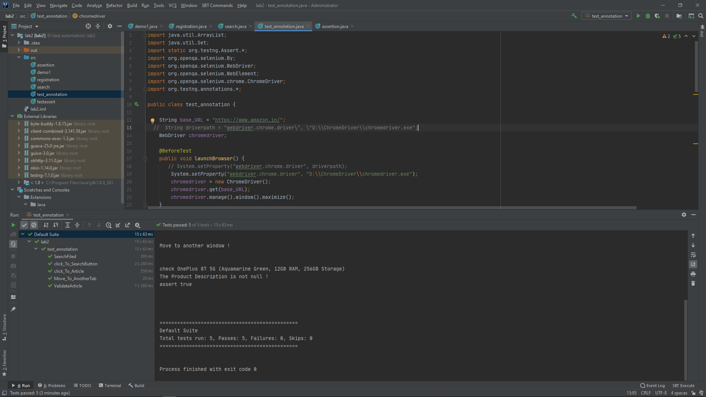

**EXPERIMENT-6**

***Title: Implement the parameterized data for the automation script build in starting***

***Content:*** ***Implement the parameterized data for the automation script build in starting. Create a parameterize annotations class to pass parameters and test***

1. **Basic data provider**

import org.testng.annotations.DataProvider;  
import org.testng.annotations.*;  
import org.openqa.selenium.By;  
public class data_provider1 {  
 @DataProvider(name="data-provider")  
 public Object[][]dpmethod(){  
 return new Object[][]{{"First Value"},{"Second Value"}};  
 }  
@Test (dataProvider = "data-provider")  
public void mytest (String val){  
 System.*out*.println("passed value is: "+val);  
}  
  
}

**Test Class**

import org.testng.annotations.Test;  
  
public class test_dp1 {  
 @Test (dataProvider = "data-provider", dataProviderClass = data_provider1.class)  
 public void myTest (String val) {  
 System.*out*.println("Current Status : " + val);  
 }  
}

**Output**

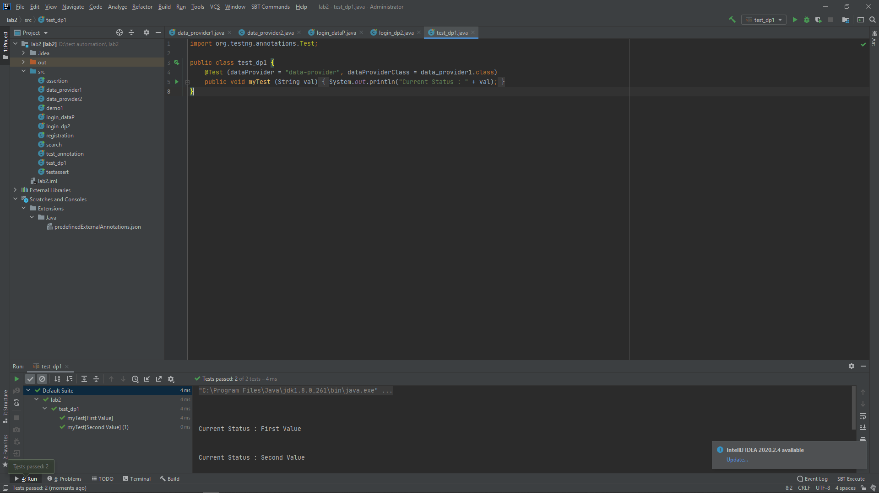

1. **Login into amazon.in**

**Data Provider**

import org.testng.annotations.DataProvider;  
import org.testng.annotations.*;  
  
public class data_provider2 {  
 @DataProvider(name="login data-provider")  
 public Object[][]getdata(){  
 Object[][] data = new Object[1][2];  
 data[0][0]="3456gaurav@gmail.com";  
 data[0][1]="*****";  
  
 return data;  
 }  
  
}

**Test class in another class**

import java.util.ArrayList;  
import java.util.Set;  
import static org.testng.Assert.*;  
import org.openqa.selenium.By;  
import org.openqa.selenium.WebDriver;  
import org.openqa.selenium.WebElement;  
import org.openqa.selenium.chrome.ChromeDriver;  
import org.testng.annotations.*;  
public class login_dp2 {  
 String base_URL = "https://www.amazon.in/";  
 WebDriver chromedriver;  
  
 @BeforeTest  
 public void launchBrowser() {  
  
 System.*setProperty*("webdriver.chrome.driver", "D:\\ChromeDriver\\chromedriver.exe");  
 chromedriver = new ChromeDriver();  
 chromedriver.get(base_URL);  
 chromedriver.manage().window().maximize();  
 }  
 @Test(priority=0)  
 public void find_signin(){  
 WebElement signin = chromedriver.findElement(By.*id*("nav-link-accountList-nav-line-1"));  
 signin.click();  
 }  
  
 @Test(priority=1,dataProvider = "login data-provider", dataProviderClass = data_provider2.class)  
 public void enter_email(String id, String password){  
 WebElement email = chromedriver.findElement(By.*id*("ap_email"));  
 email.sendKeys(id);  
 }  
  
 @Test(priority=2)  
 public void continue_signin(){  
 WebElement continue1 = chromedriver.findElement(By.*id*("continue"));  
 continue1.click();  
 }  
  
 @Test(priority=3,dataProvider = "login data-provider", dataProviderClass = data_provider2.class)  
 public void enter_password(String id, String password){  
 WebElement email = chromedriver.findElement(By.*id*("ap_password"));  
 email.sendKeys(password);  
 }  
  
 @Test(priority=4)  
 public void submit_signin(){  
 WebElement submit = chromedriver.findElement(By.*id*("signInSubmit"));  
 submit.click();  
 }  
  
 @AfterTest  
 public void Quite() {  
 chromedriver.quit();  
 }  
  
  
}

**Output**

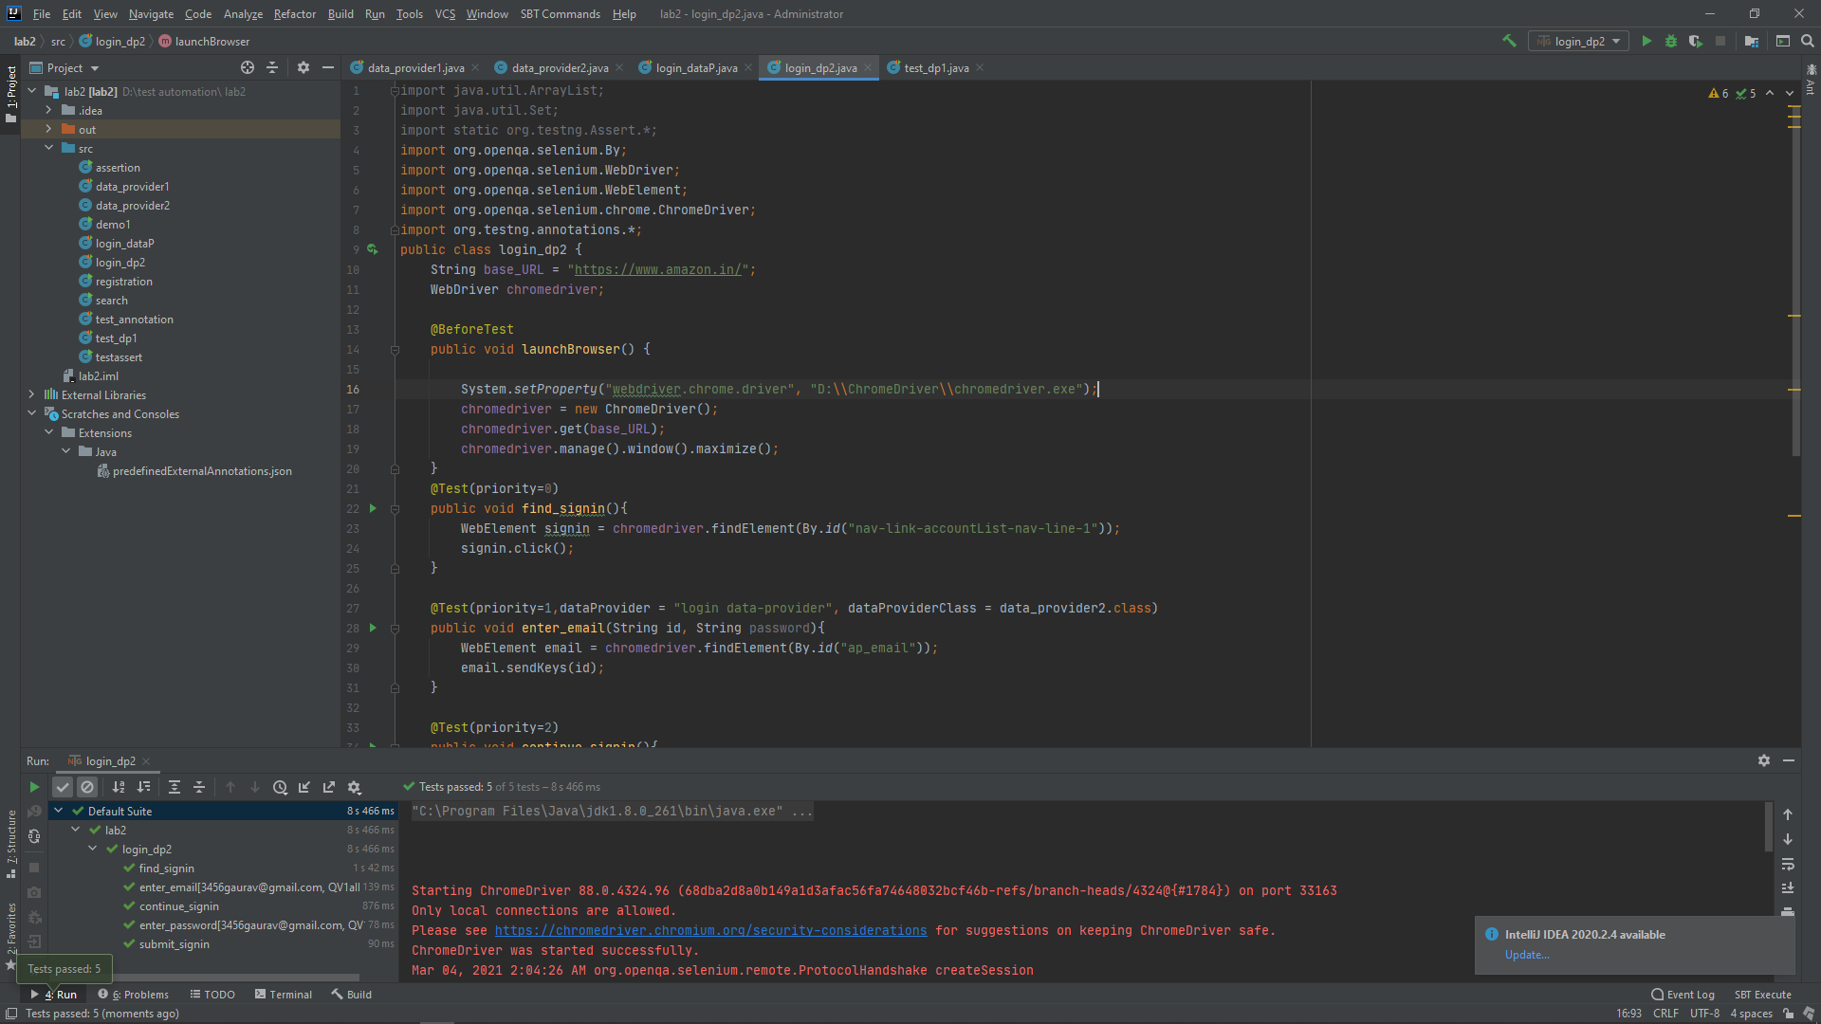

**Test class and data provider in same class**

import org.openqa.selenium.By;  
import org.openqa.selenium.WebDriver;  
import org.openqa.selenium.WebElement;  
import org.openqa.selenium.chrome.ChromeDriver;  
import org.testng.annotations.*;  
public class login_dataP{  
 @DataProvider(name="login data-provider")  
 public Object[][]getdata(){  
 Object[][] data = new Object[1][2];  
 data[0][0]="3456gaurav@gmail.com";  
 data[0][1]="******";  
  
 return data;  
 }  
  
 String base_URL = "https://www.amazon.in/";  
 WebDriver chromedriver;  
  
 @BeforeTest  
 public void launchBrowser() {  
  
 System.*setProperty*("webdriver.chrome.driver", "D:\\ChromeDriver\\chromedriver.exe");  
 chromedriver = new ChromeDriver();  
 chromedriver.get(base_URL);  
 chromedriver.manage().window().maximize();  
 }  
 @Test(priority=0)  
 public void find_signin(){  
 WebElement signin = chromedriver.findElement(By.*id*("nav-link-accountList-nav-line-1"));  
 signin.click();  
 }  
  
 @Test(priority=1,dataProvider = "login data-provider", dataProviderClass = data_provider2.class)  
 public void enter_email(String id, String password){  
 WebElement email = chromedriver.findElement(By.*id*("ap_email"));  
 email.sendKeys(id);  
 }  
  
 @Test(priority=2)  
 public void continue_signin(){  
 WebElement continue1 = chromedriver.findElement(By.*id*("continue"));  
 continue1.click();  
 }  
  
 @Test(priority=3,dataProvider = "login data-provider", dataProviderClass = data_provider2.class)  
 public void enter_password(String id, String password){  
 WebElement email = chromedriver.findElement(By.*id*("ap_password"));  
 email.sendKeys(password);  
 }  
  
 @Test(priority=4)  
 public void submit_signin(){  
 WebElement submit = chromedriver.findElement(By.*id*("signInSubmit"));  
 submit.click();  
 }  
  
 @AfterTest  
 public void Quite() {  
 chromedriver.quit();  
 }  
}

**Output**

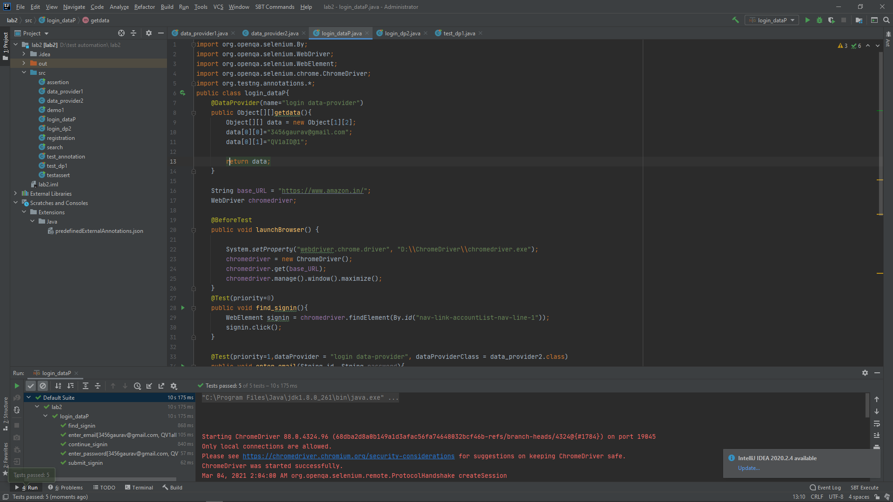

**EXPERIMENT-7**

**Tittle:** login to amazon.in using “firefox driver” and “Microsoft edge driver”

**NOTE:** selenium does not support internet explorer

1. **FIREFOX DRIVER**

**CODE**

import org.openqa.selenium.By;  
 import org.openqa.selenium.JavascriptExecutor;  
 import org.openqa.selenium.WebDriver;  
 import org.openqa.selenium.WebElement;  
import org.openqa.selenium.firefox.FirefoxDriver;  
  
  
public class firefox_login {  
  
 public static void main(String[] args) {  
  
 // System Property for Chrome Driver  
 System.*setProperty*("webdriver.gecko.driver", "D:\\geckodriver.exe");  
 WebDriver driver = new FirefoxDriver();  
 // Launch Website  
 driver.navigate().to("https://www.amazon.in/");  
 driver.manage().window().maximize();  
 System.*out*.println("1");  
 WebElement signin = driver.findElement(By.*id*("nav-link-accountList-nav-line-1"));  
 signin.click();  
 System.*out*.println("2");  
 WebElement email = driver.findElement(By.*id*("ap_email"));  
 email.sendKeys("*****");  
 System.*out*.println("3");  
 WebElement continu = driver.findElement(By.*id*("continue"));  
 continu.click();  
 System.*out*.println("4");  
 WebElement pswd = driver.findElement(By.*id*("ap_password"));  
 pswd.sendKeys("*******");  
 System.*out*.println("5");  
 WebElement signin1 = driver.findElement(By.*id*("signInSubmit"));  
 signin1.click();  
 System.*out*.println("6");  
 }}

**OUTPUT**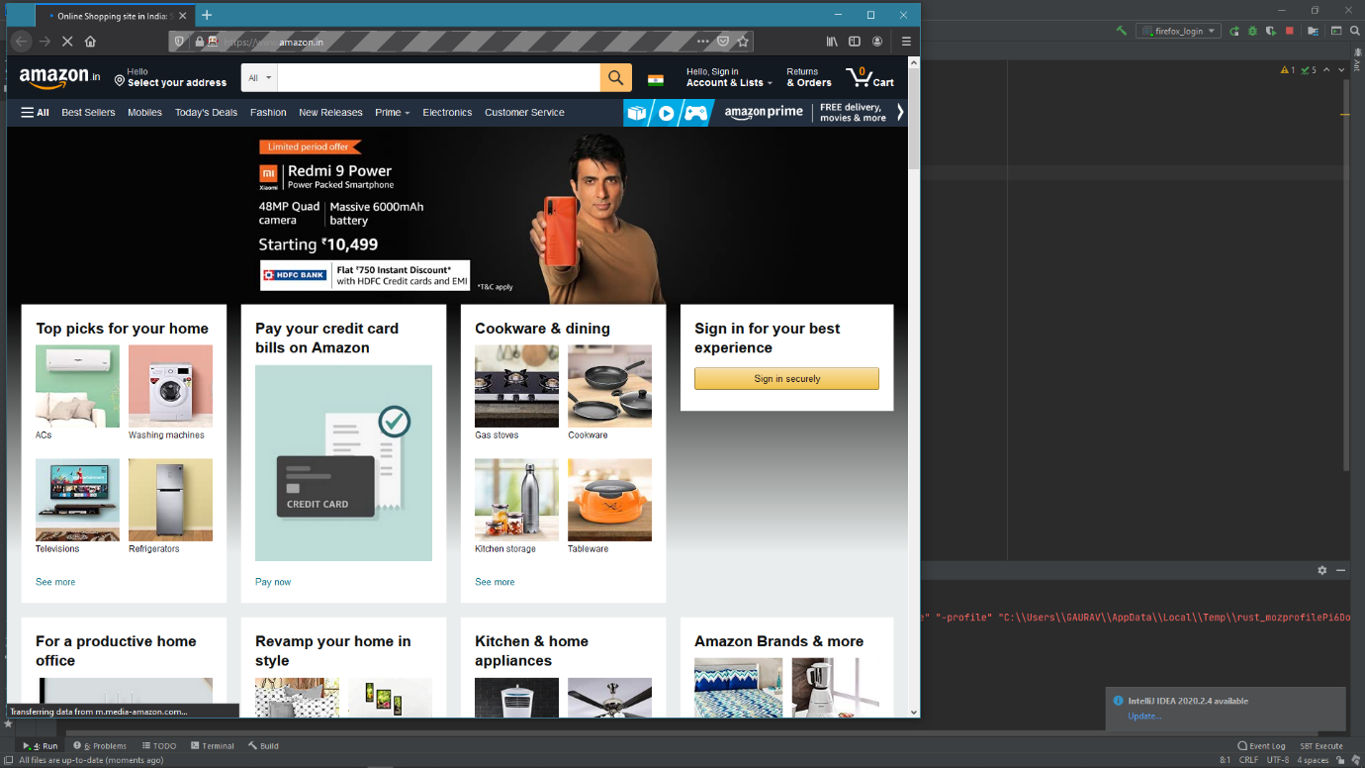

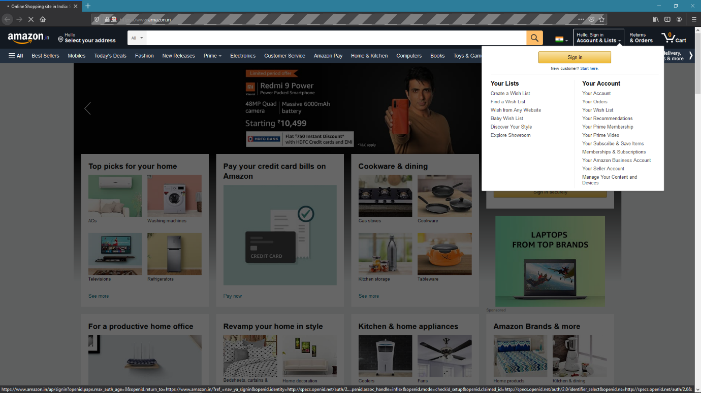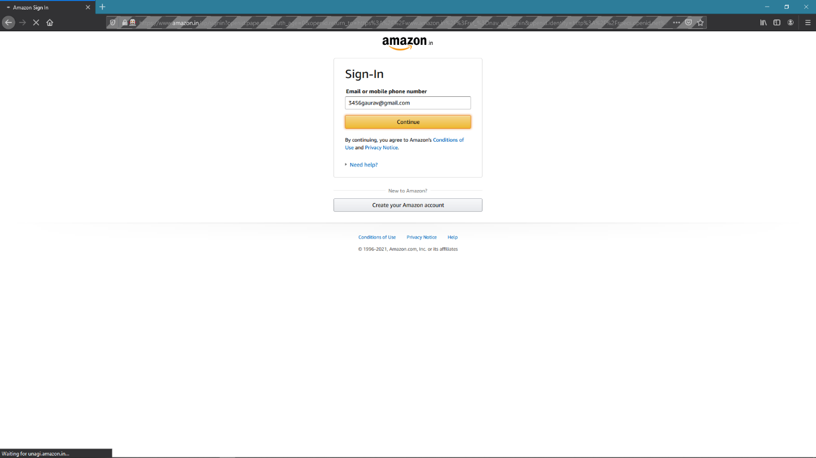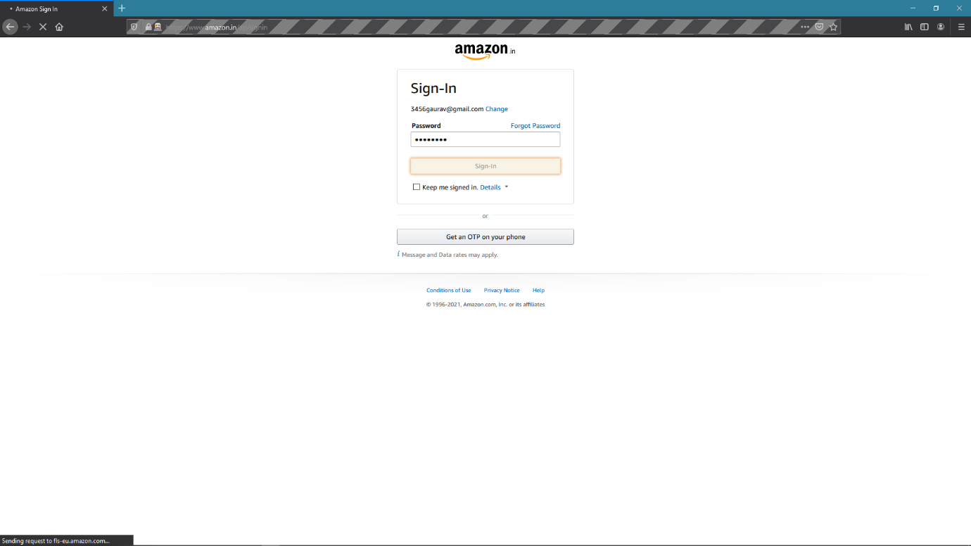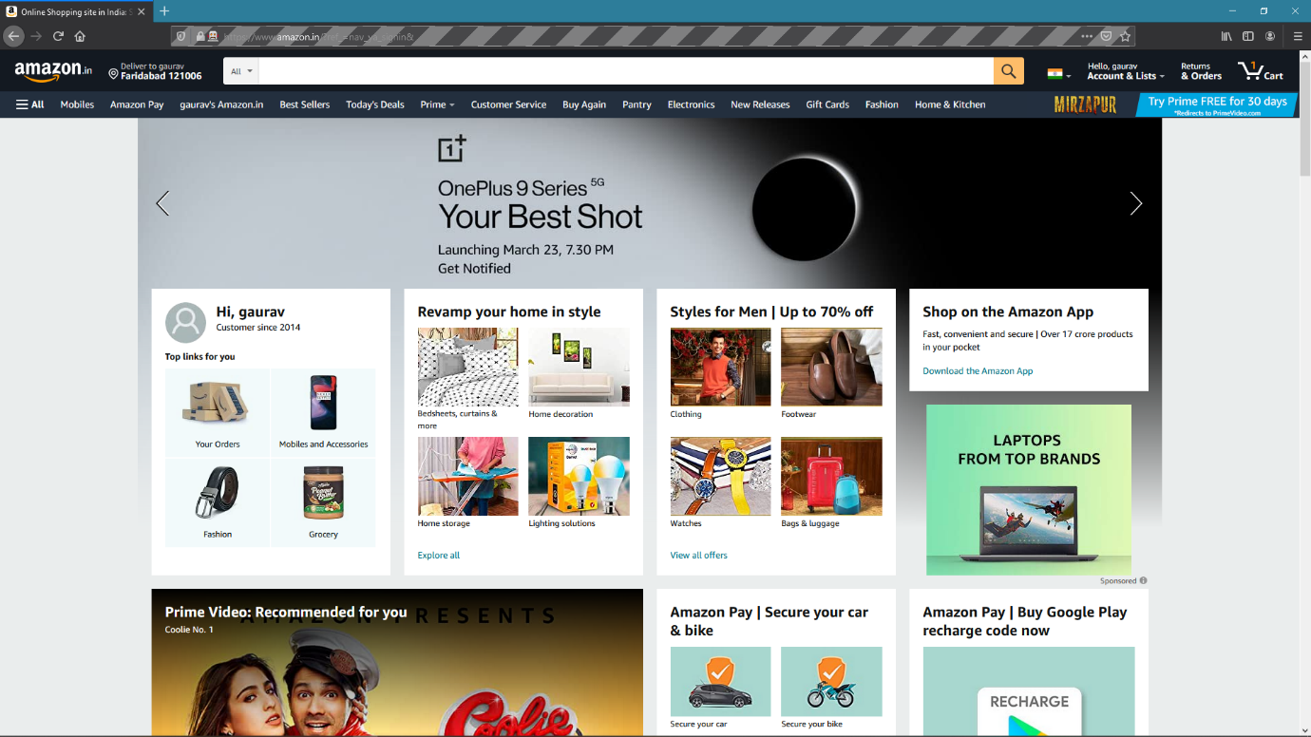

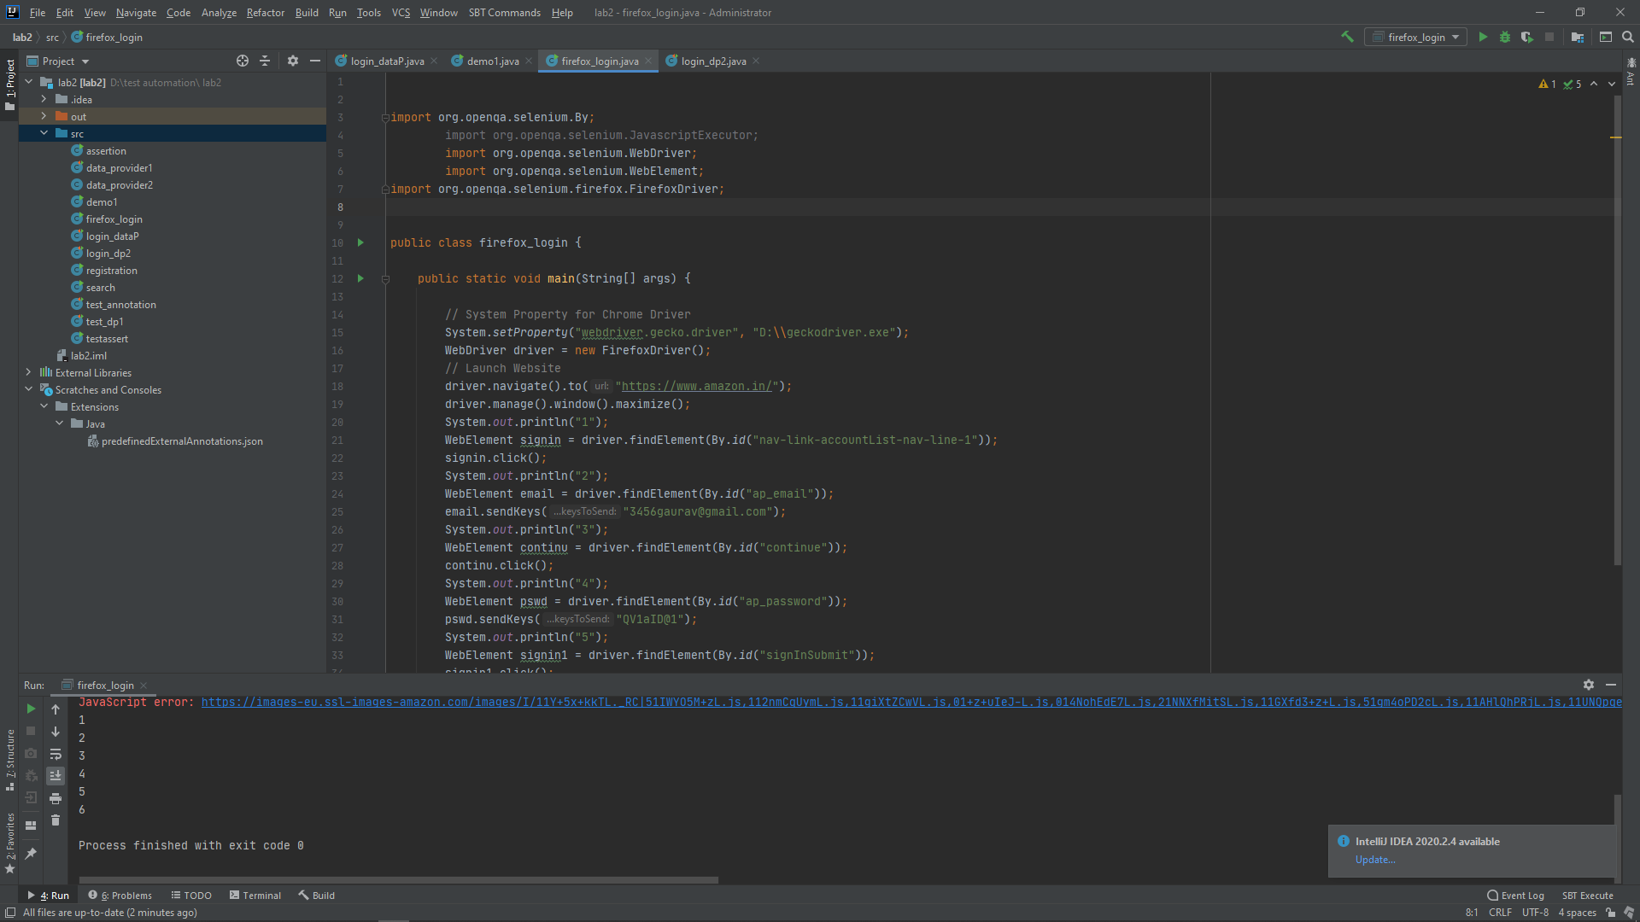

1. **MICROSOFT EDGE DRIVER**

**CODE**

import org.openqa.selenium.By;  
 import org.openqa.selenium.JavascriptExecutor;  
 import org.openqa.selenium.WebDriver;  
 import org.openqa.selenium.WebElement;  
import org.openqa.selenium.firefox.FirefoxDriver;  
import org.openqa.selenium.ie.InternetExplorerDriver;  
import org.openqa.selenium.edge.EdgeDriver;  
  
public class firefox_login {  
  
 public static void main(String[] args) {  
  
 // System Property for Chrome Driver  
 System.*setProperty*("webdriver.edge.driver", "D:\\msedgedriver.exe");  
 // Launch Website  
 WebDriver driver = new EdgeDriver();  
 driver.navigate().to("https://www.amazon.in/");  
 driver.manage().window().maximize();  
 System.*out*.println("1");  
 WebElement signin = driver.findElement(By.*id*("nav-link-accountList-nav-line-1"));  
 signin.click();  
 System.*out*.println("2");  
 WebElement email = driver.findElement(By.*id*("ap_email"));  
 email.sendKeys("");  
 System.*out*.println("3");  
 WebElement continu = driver.findElement(By.*id*("continue"));  
 continu.click();  
 System.*out*.println("4");  
 WebElement pswd = driver.findElement(By.*id*("ap_password"));  
 pswd.sendKeys("");  
 System.*out*.println("5");  
 WebElement signin1 = driver.findElement(By.*id*("signInSubmit"));  
 signin1.click();  
 System.*out*.println("6");  
 }}

**OUTPUT**

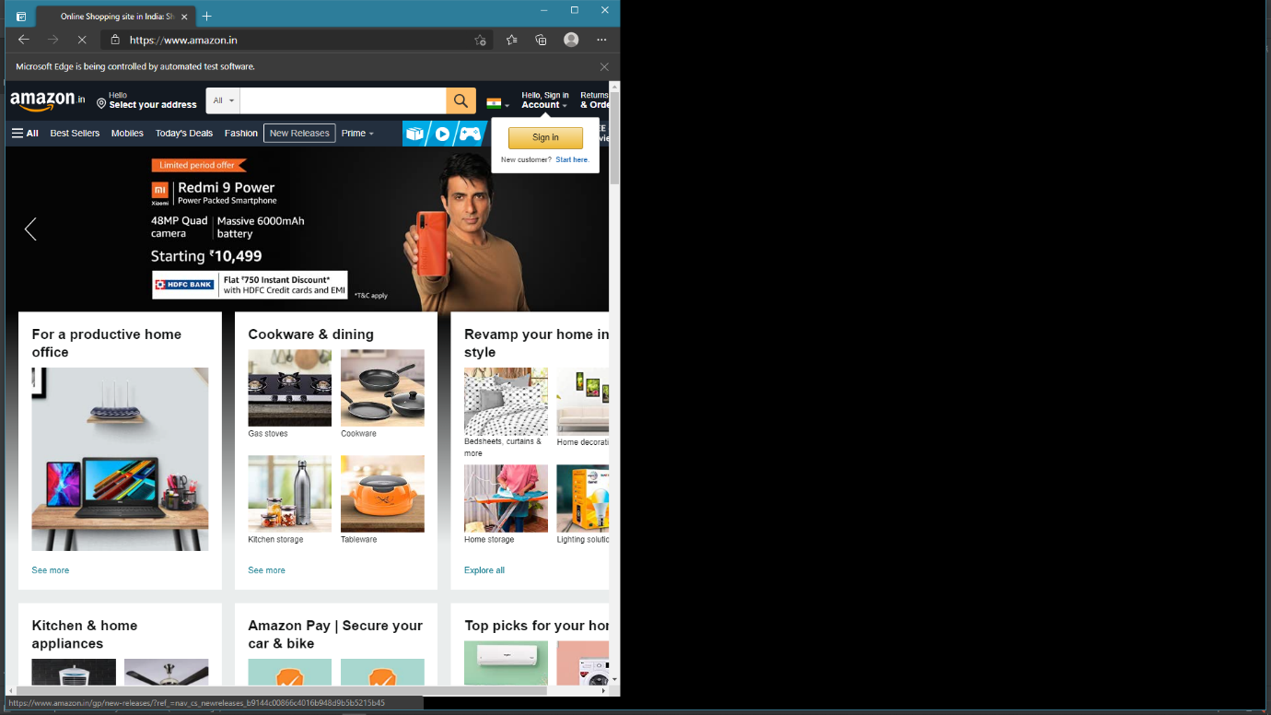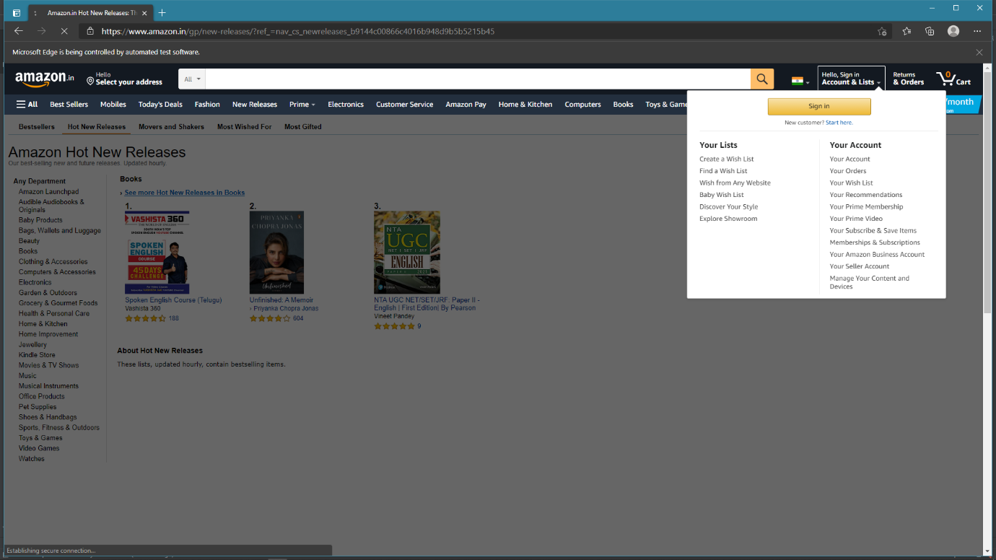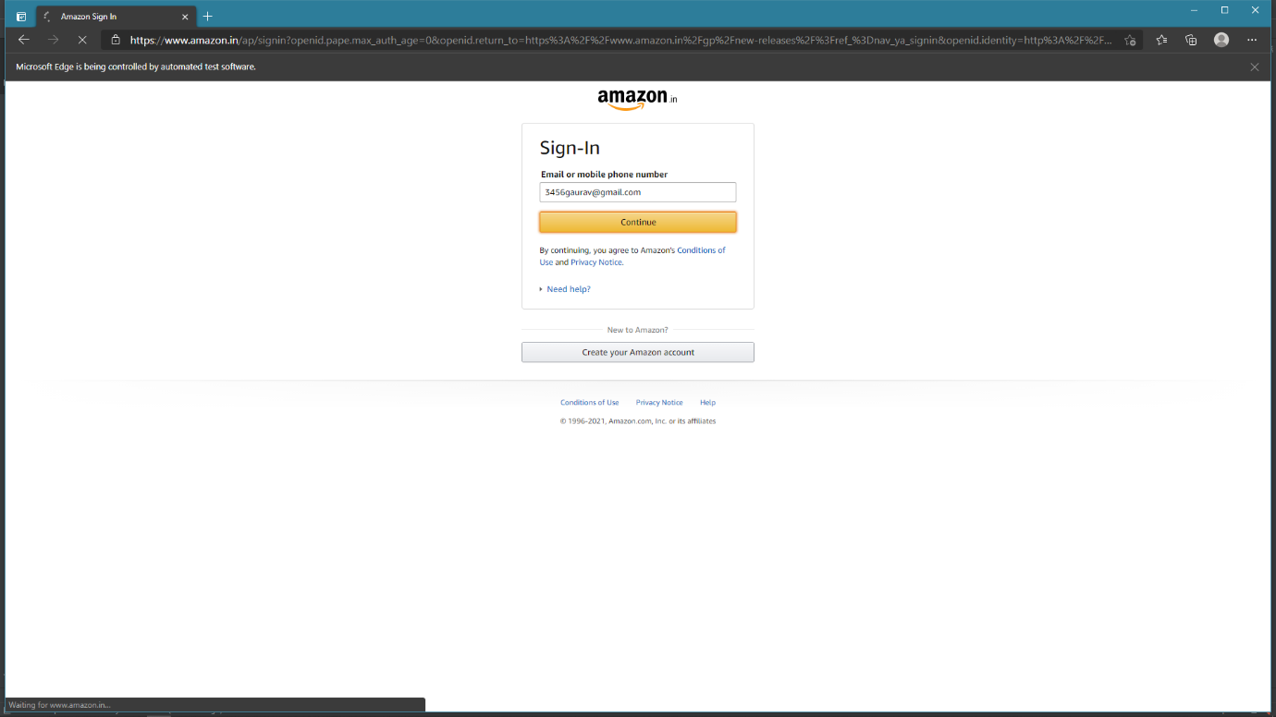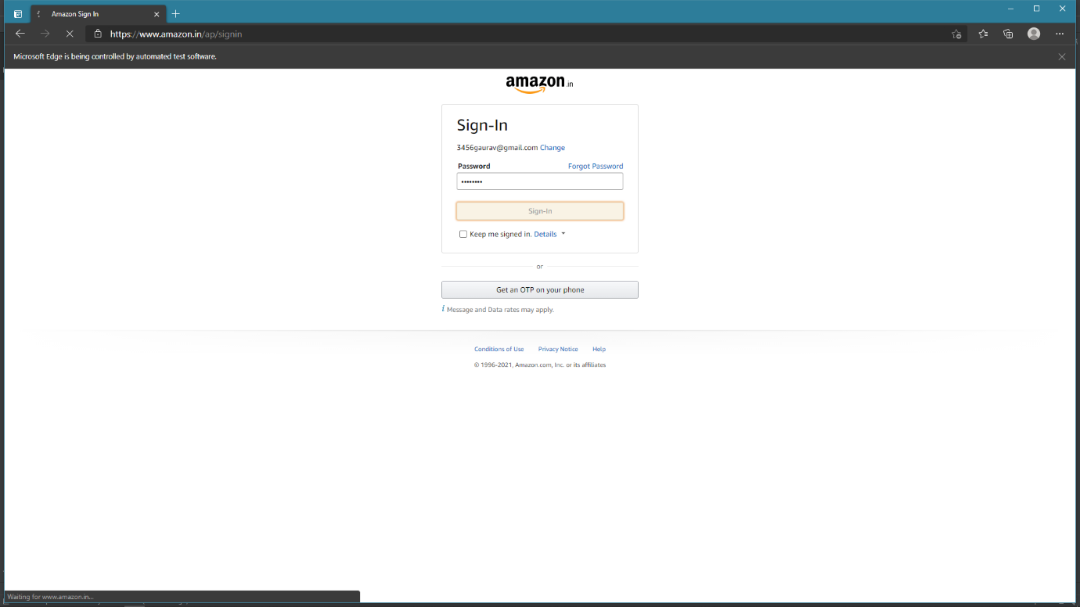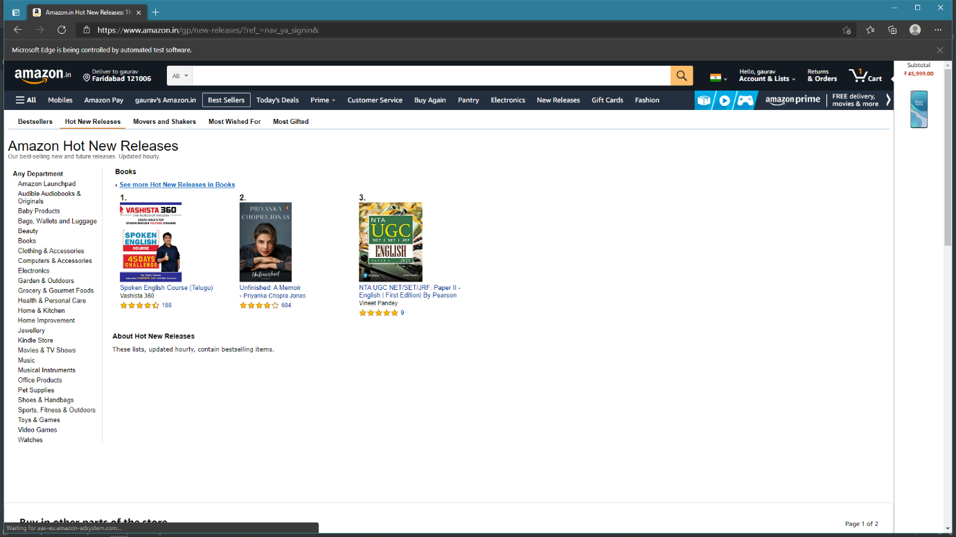

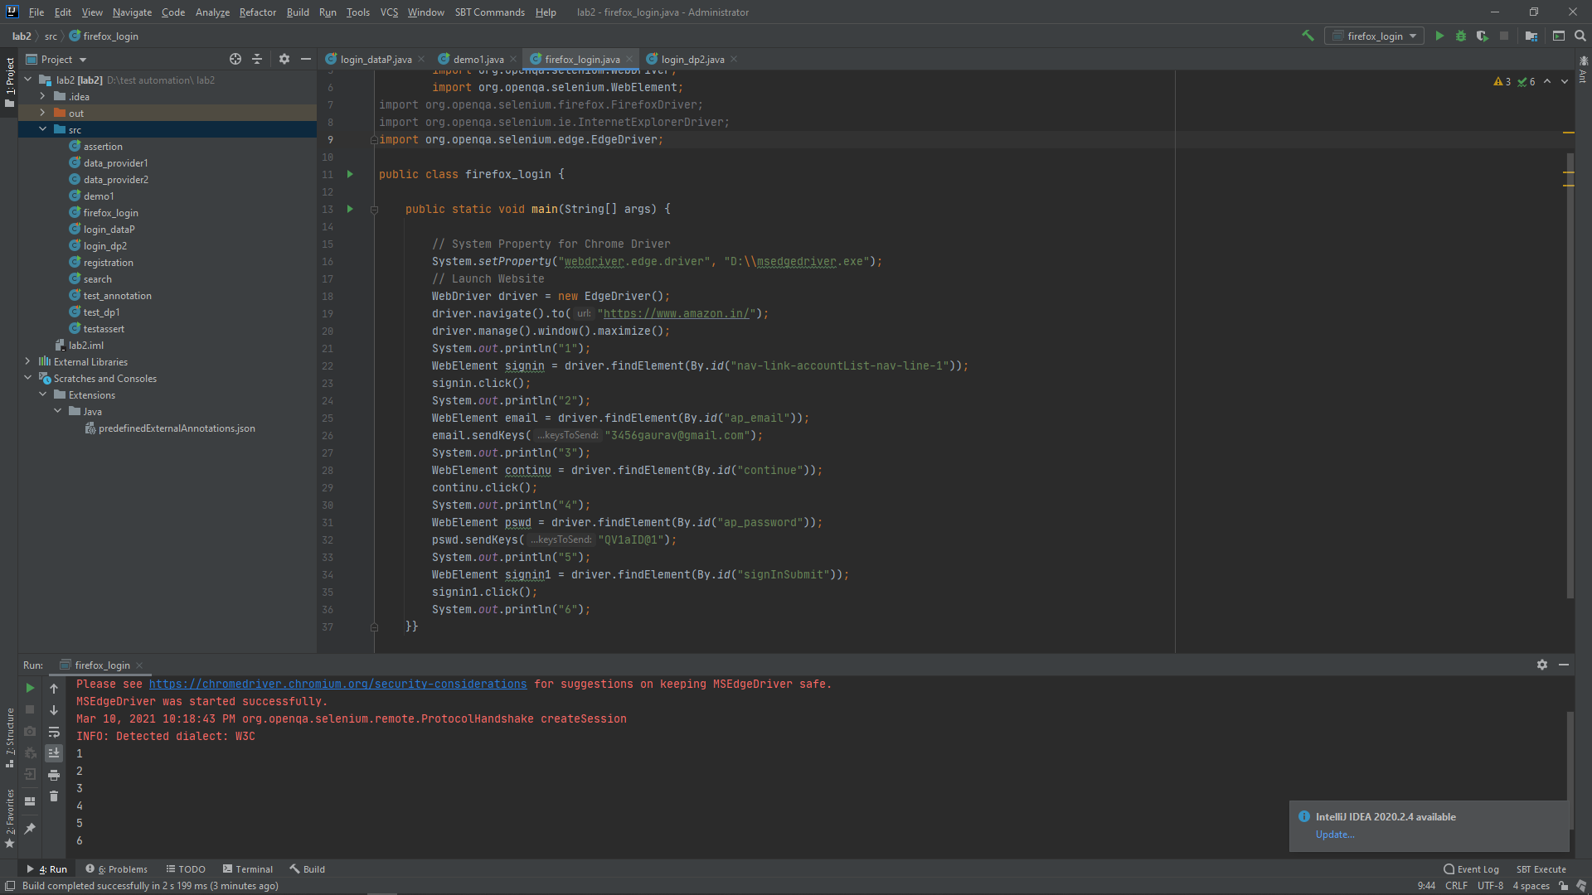

**EXPERIMENT-8**

**Tittle:** Use the data driven test automation framework to parameterize

the data using data from an Excel Sheet (LOGIN TO AMAZON)

**CODE**

import java.io.FileInputStream;  
 import java.io.FileNotFoundException;  
 import java.io.IOException;  
 import org.apache.poi.ss.usermodel.CellType;  
 import org.apache.poi.xssf.usermodel.XSSFRow;  
 import org.apache.poi.xssf.usermodel.XSSFSheet;  
 import org.apache.poi.xssf.usermodel.XSSFWorkbook;  
 import org.openqa.selenium.By;  
 import org.openqa.selenium.WebDriver;  
 import org.openqa.selenium.WebElement;  
 import org.openqa.selenium.chrome.ChromeDriver;  
public class read_data {  
  
 static WebDriver *driver*;  
  
 void setup() {  
 System.*setProperty*("webdriver.chrome.driver", "D:\\ChromeDriver\\chromedriver.exe");  
 }  
  
 void checkLogin(String username, String pw) {  
  
 *driver*=new ChromeDriver();  
  
 *driver*.get("https://www.amazon.in/");  
  
 *driver*.manage().window().maximize();  
  
 System.*out*.println("1");  
 WebElement signin = *driver*.findElement(By.*id*("nav-link-accountList-nav-line-1"));  
 signin.click();  
  
 System.*out*.println("2");  
 WebElement email = *driver*.findElement(By.*id*("ap_email"));  
 email.sendKeys(username);  
 System.*out*.println("3");  
 WebElement continu = *driver*.findElement(By.*id*("continue"));  
 continu.click();  
 System.*out*.println("4");  
 WebElement pswd = *driver*.findElement(By.*id*("ap_password"));  
 pswd.sendKeys(pw);  
 System.*out*.println("5");  
 WebElement signin1 = *driver*.findElement(By.*id*("signInSubmit"));  
 signin1.click();  
 System.*out*.println("6");  
  
 *driver*.quit();  
 }  
 public static void main(String[] args) throws IOException {  
  
  
 (new read_data()).setup();  
  
 try {  
  
 FileInputStream file= new FileInputStream("C:\\Users\\GAURAV\\OneDrive\\Desktop\\Documents\\Test Automation\\DataRead.xlsx");  
  
 XSSFWorkbook wb = new XSSFWorkbook(file);  
  
 XSSFSheet sheet=wb.getSheet("Login");  
  
 String username,password;  
  
// System.out.println(sheet.getLastRowNum());  
  
 for(int i=1;i<=sheet.getLastRowNum();i++) {  
  
 XSSFRow row=sheet.getRow(i);  
  
 if(row.getCell(0).getCellType() == CellType.*NUMERIC*) {  
 username=row.getCell(0).getRawValue().toString();  
 }  
 else {  
 username=row.getCell(0).toString();  
 }  
  
 password=row.getCell(1).getStringCellValue();  
 System.*out*.println("Username: " + username);  
 System.*out*.println("Password: " + password);  
  
  
 (new read_data()).checkLogin(username,password);  
 System.*out*.println("Test successful");  
 }  
 }  
  
 catch (FileNotFoundException e) {  
 e.printStackTrace();  
 }  
  
  
 }  
}

**OUTPUT**

**(Excel Data sheet)**

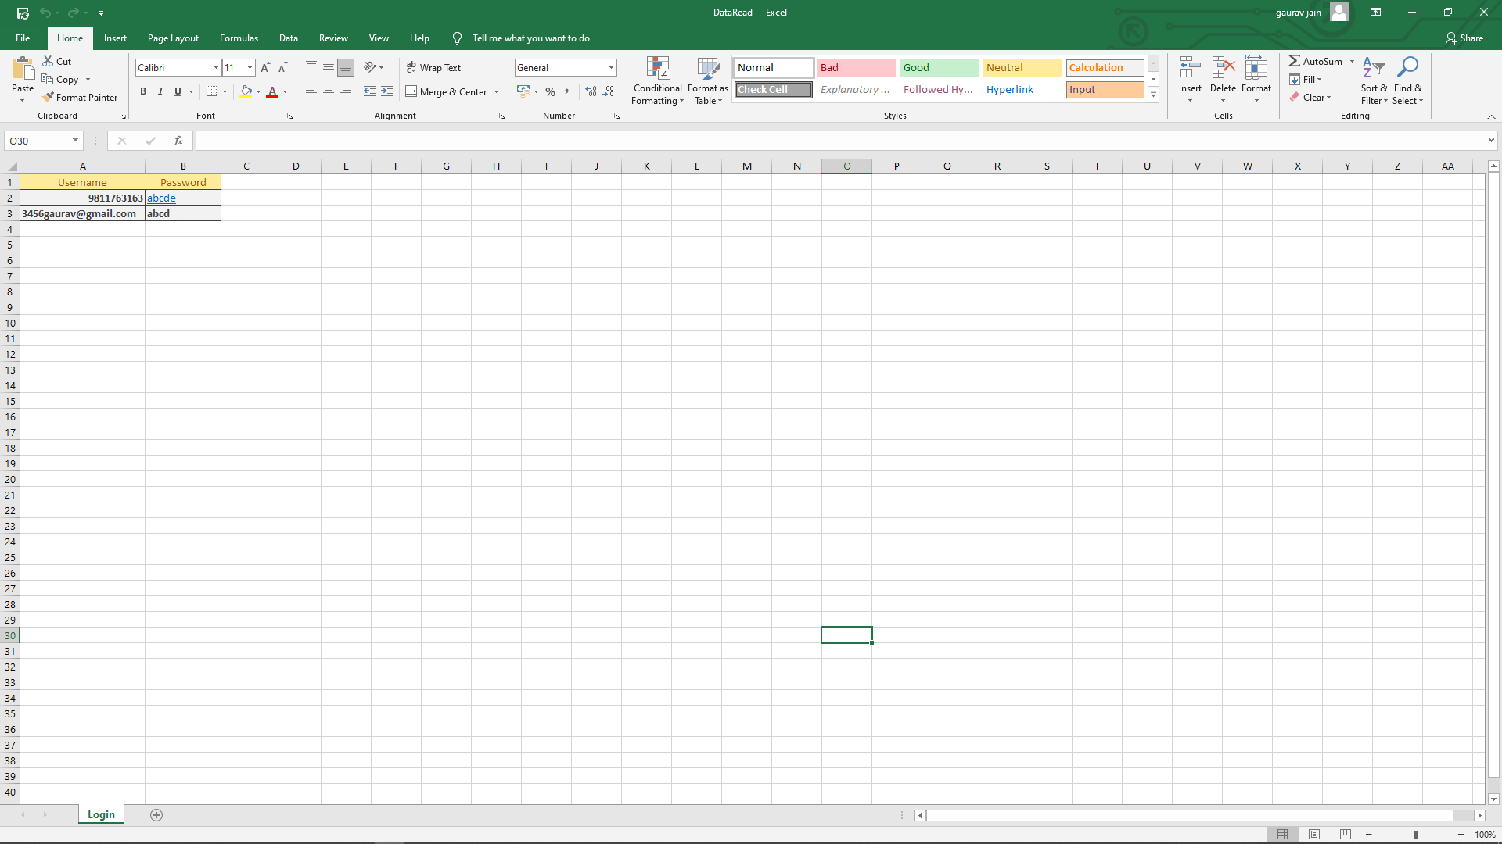

**( Test Case 1 )**

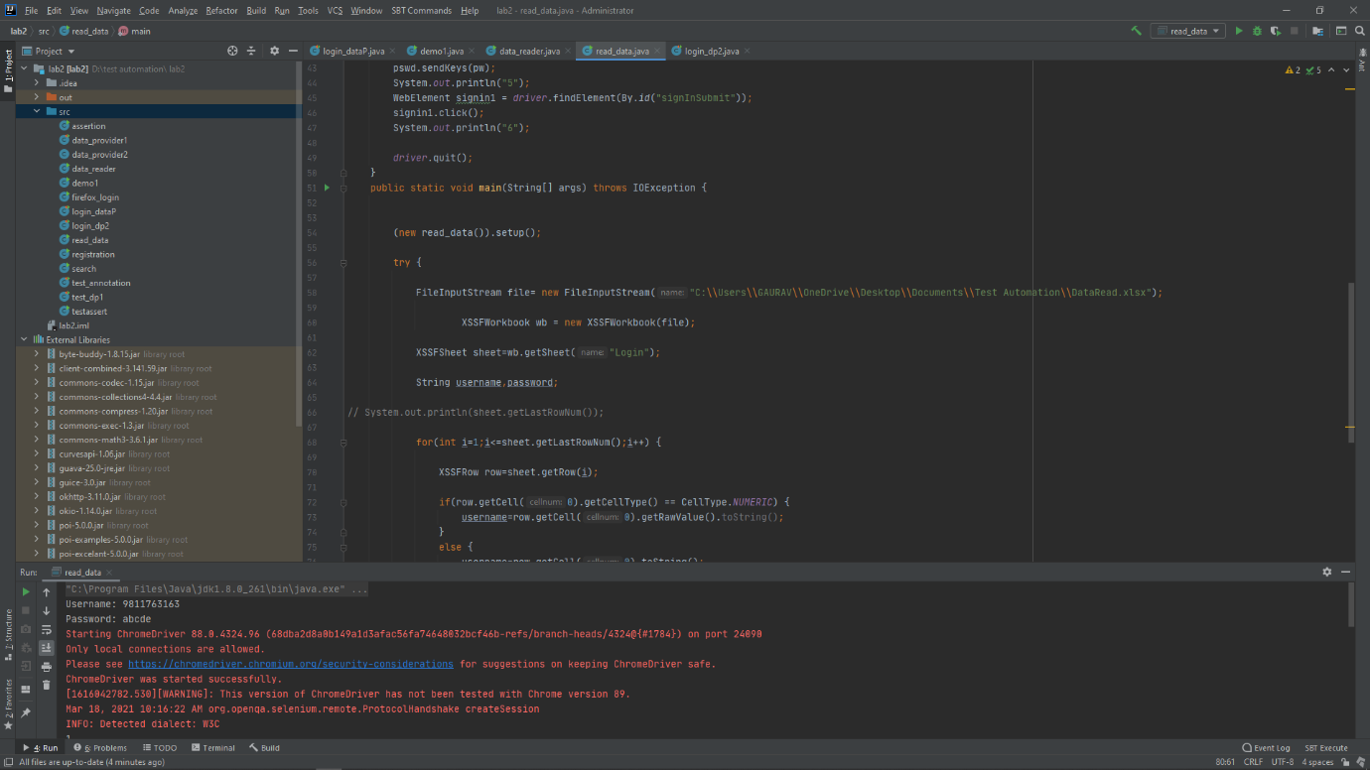

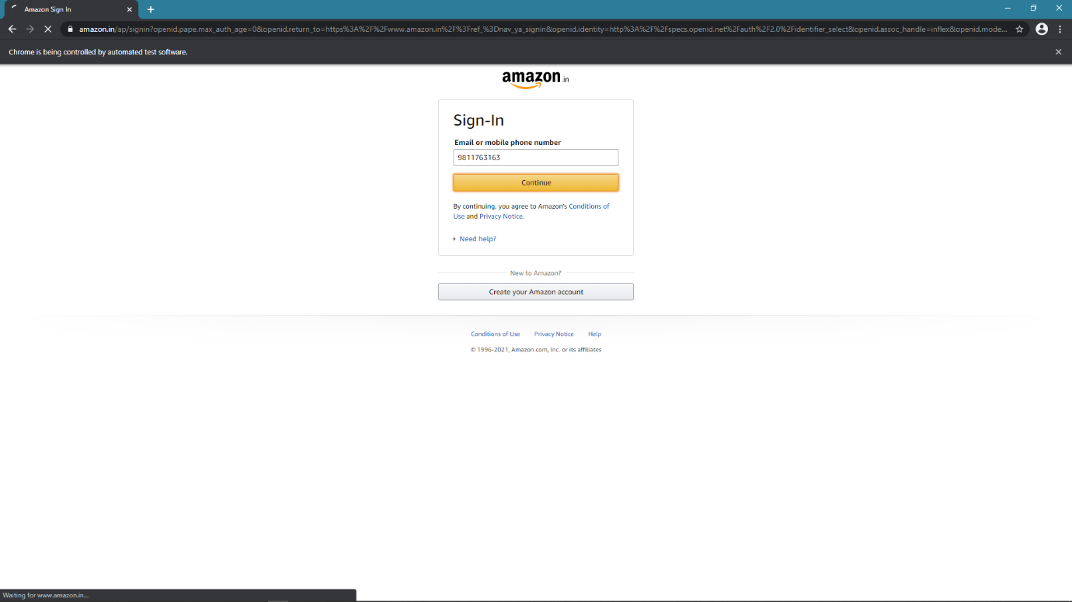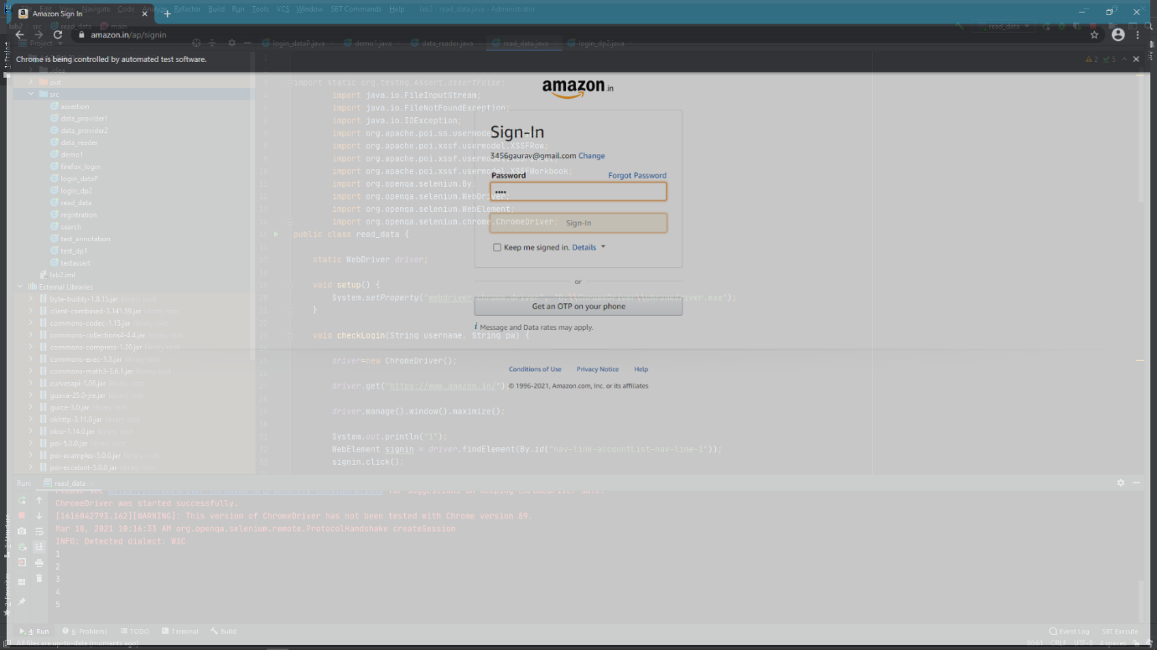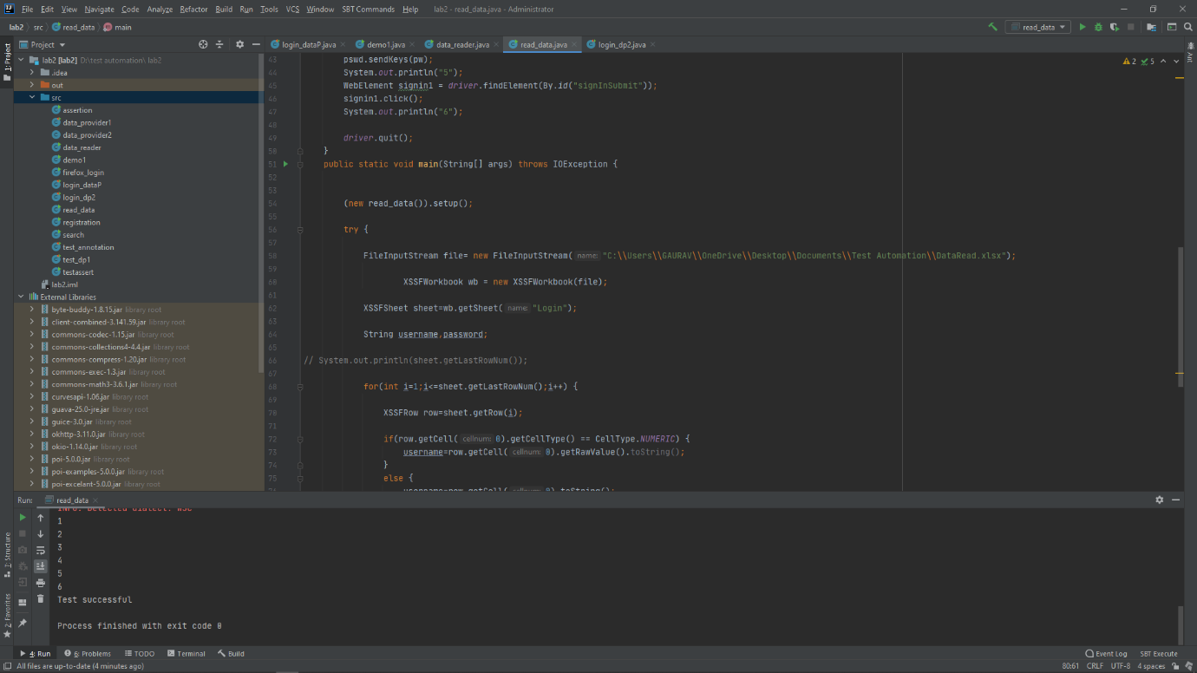

**( Test Case 2 )**

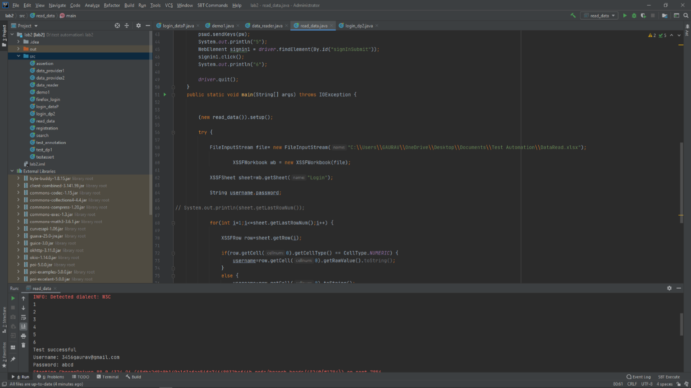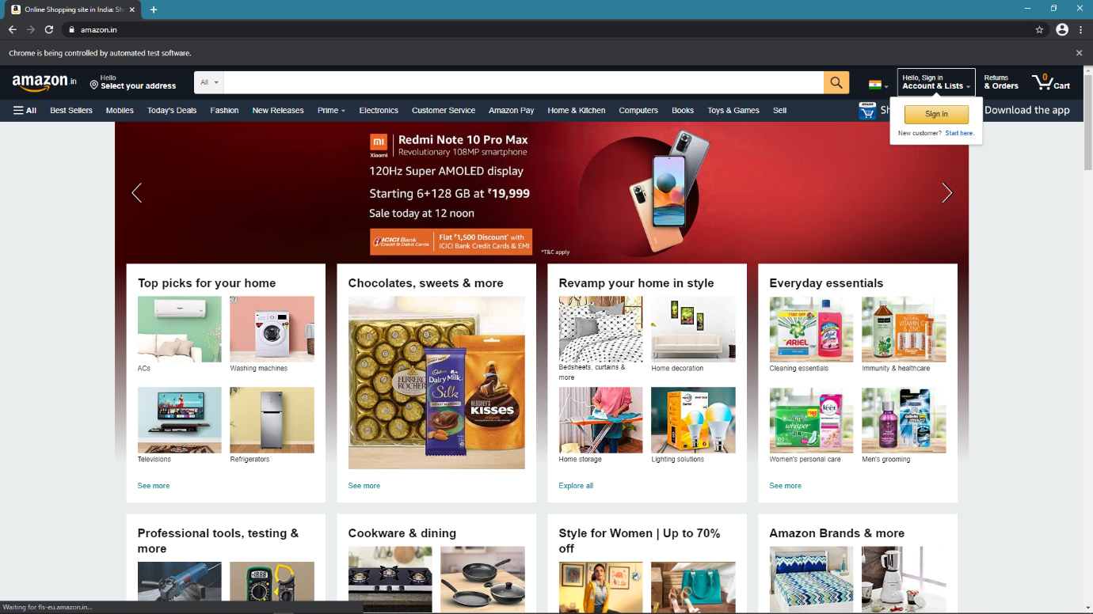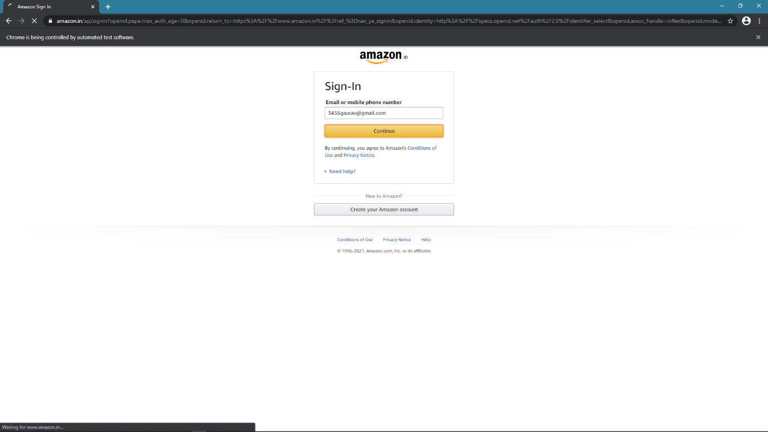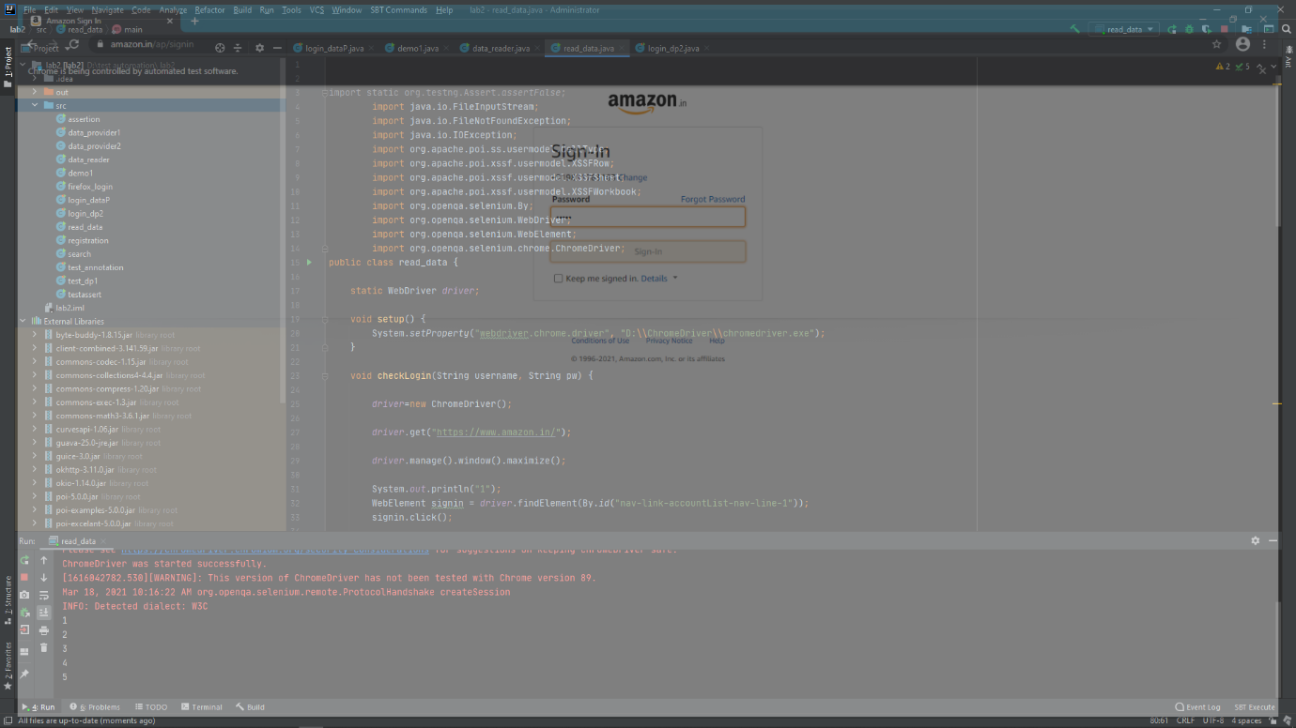 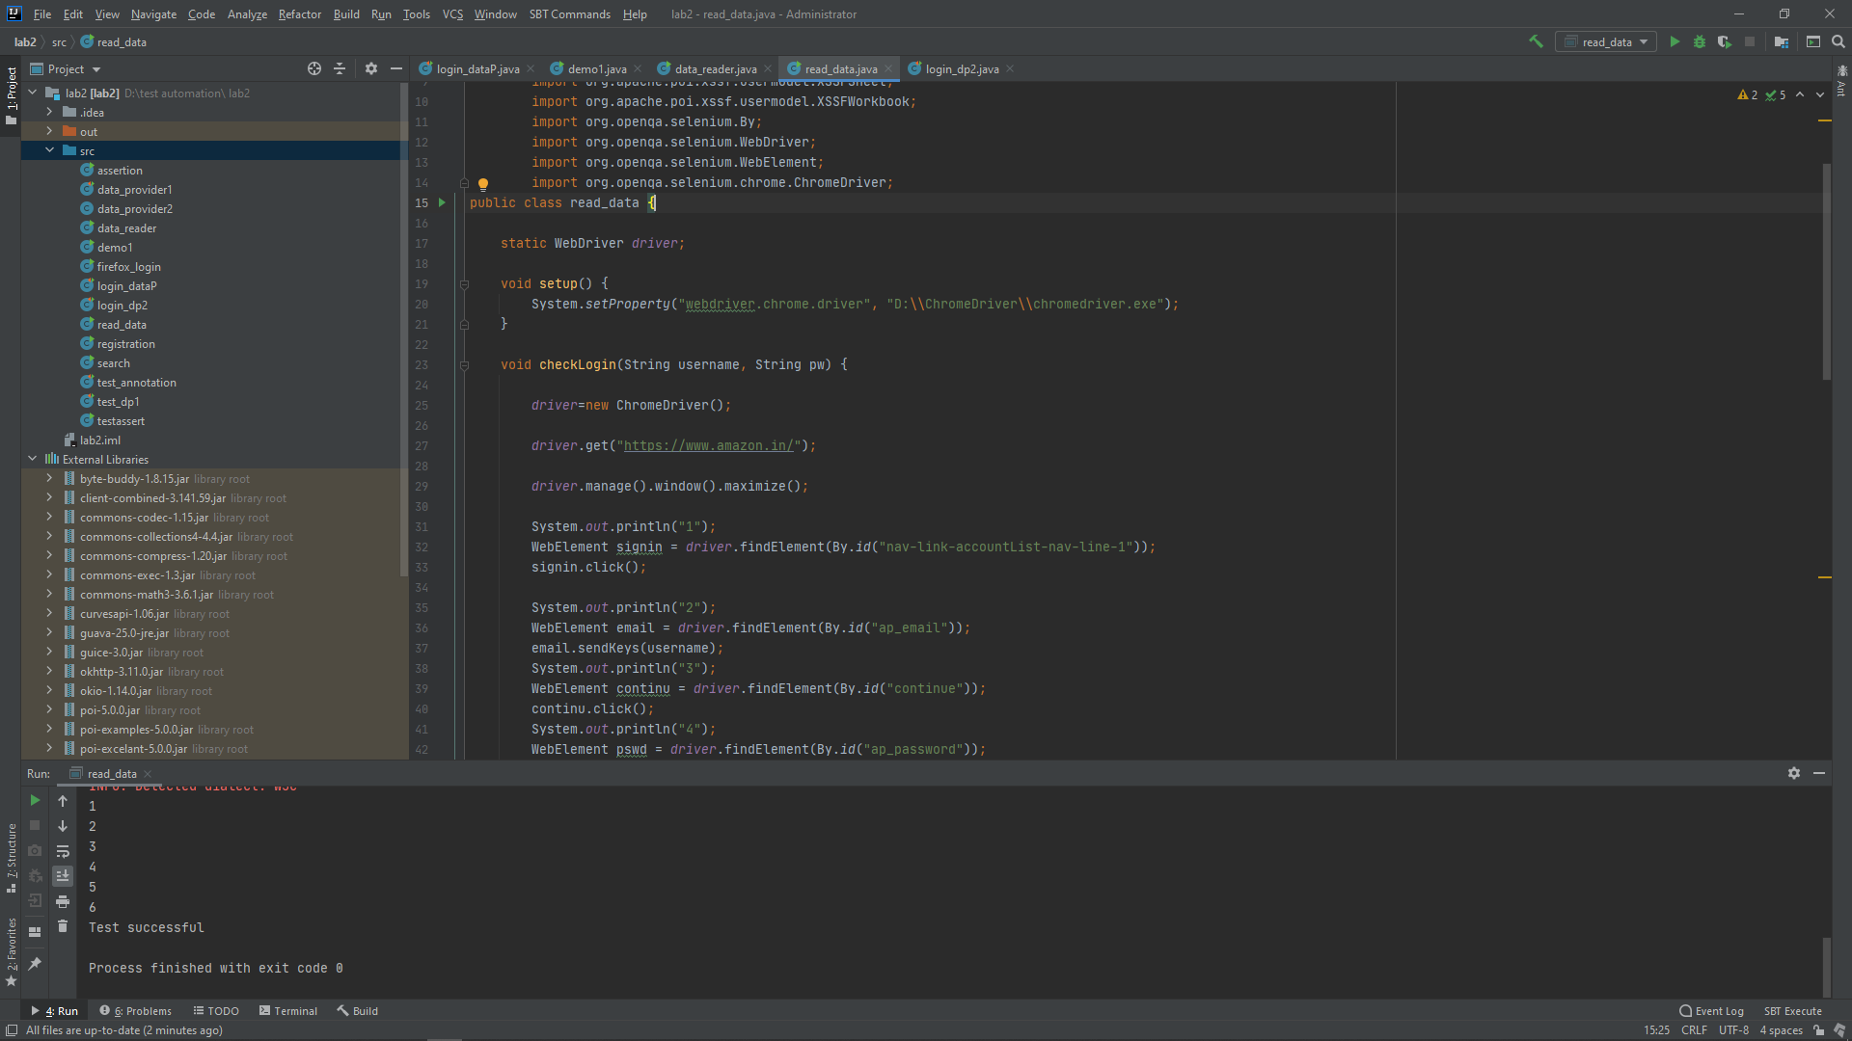

**EXPERIMENT-9**

***Title: Integrate extent report with automation scripts for result reporting.***

**Code**

import java.lang.reflect.Method;  
  
import org.openqa.selenium.By;  
import org.openqa.selenium.WebDriver;  
import org.openqa.selenium.WebElement;  
import org.openqa.selenium.chrome.ChromeDriver;  
import org.testng.annotations.AfterMethod;  
import org.testng.annotations.AfterTest;  
import org.testng.annotations.BeforeClass;  
import org.testng.annotations.BeforeMethod;  
import org.testng.annotations.BeforeTest;  
import org.testng.annotations.Test;  
  
import com.relevantcodes.extentreports.ExtentReports;  
import com.relevantcodes.extentreports.ExtentTest;  
import com.relevantcodes.extentreports.LogStatus;  
  
public class TestNG_Report {  
  
 static ExtentReports *report*;  
 static ExtentTest *test*;  
  
 WebDriver driver;  
 String baseurl="https://www.amazon.in/";  
 String driverpath="D:\\ChromeDriver\\chromedriver.exe";  
  
 @BeforeClass  
 public void initReport(){  
 *report* = new ExtentReports("/Users/sumyak/Desktop/Test_Automation/report.html");  
 }  
  
 @BeforeTest  
 public void launchBrowser(){  
 System.*setProperty*("webdriver.chrome.driver",driverpath);  
 driver=new ChromeDriver();  
 driver.get(baseurl);  
 driver.manage().window().maximize();  
 }  
  
 @BeforeMethod  
 public static void startReport(Method result){  
 *test* = *report*.startTest("Extent Report - "+result.getName());  
 }  
  
 @AfterMethod  
 public void endReport(){  
 *report*.endTest(*test*);  
 *report*.flush();  
 }  
  
 @Test(priority=0)  
 public void clickSignin(){  
 driver.findElement(By.*id*("nav-link-accountList-nav-line-1")).click();  
 *test*.log(LogStatus.INFO, "Starting login");  
  
 if(driver.findElement(By.*id*("ap_email"))!=null){  
 *test*.log(LogStatus.PASS, "Email input box present");  
 }  
 else{  
 *test*.log(LogStatus.FAIL, "Email input box absent");  
 }  
  
 *test*.log(LogStatus.WARNING, "Moving to next step");  
 }  
  
 @Test(priority=1)  
 public void enterUsername(){  
  
 driver.findElement(By.*id*("ap_email")).sendKeys("isshuchoudhary99@gmail.com");  
  
 if(driver.findElement(By.*id*("ap_email")).getAttribute("value").equals("isshuchoudhary99@gmail.com")){  
 *test*.log(LogStatus.PASS, "Entered email successfully");  
 }  
 else{  
 *test*.log(LogStatus.FAIL, "Couldn't enter email");  
 }  
 *test*.log(LogStatus.WARNING, "Moving to next step");  
 }  
  
 @Test(priority=2)  
 public void clickContinue(){  
 WebElement btn=driver.findElement(By.*id*("continue"));  
 if(btn!=null && btn.isEnabled()){  
 *test*.log(LogStatus.PASS, "Email submit button present and Enabled");  
 driver.findElement(By.*id*("continue")).click();  
 }  
 else{  
 *test*.log(LogStatus.FAIL, "Email submit button absent or Disabled");  
 }  
  
 *test*.log(LogStatus.WARNING, "Moving to next step");  
 }  
  
 @Test(priority=3)  
 public void enterPassword(){  
  
 driver.findElement(By.*id*("ap_password")).sendKeys("rsb1699#");  
  
 if(!driver.findElement(By.*id*("ap_password")).getAttribute("value").equals("")){  
 *test*.log(LogStatus.PASS, "Entered password successfully");  
 }  
 else{  
 *test*.log(LogStatus.FAIL, "Couldn't enter password");  
 }  
 *test*.log(LogStatus.WARNING, "Moving to next step");  
 }  
  
 @Test(priority=4)  
 public void clickLogin(){  
 WebElement btn=driver.findElement(By.*id*("signInSubmit"));  
  
 if(btn!=null && btn.isEnabled()){  
 *test*.log(LogStatus.PASS, "Email submit button present and Enabled");  
 driver.findElement(By.*id*("signInSubmit")).click();  
 }  
 else{  
 *test*.log(LogStatus.FAIL, "Email submit button absent or Disabled");  
 }  
  
 *test*.log(LogStatus.WARNING, "Login Successful");  
 }  
  
 @AfterTest  
 public void destroySession(){  
 driver.close();  
 }  
  
  
  
}

**OUTPUT**

***TestNG Report:-***

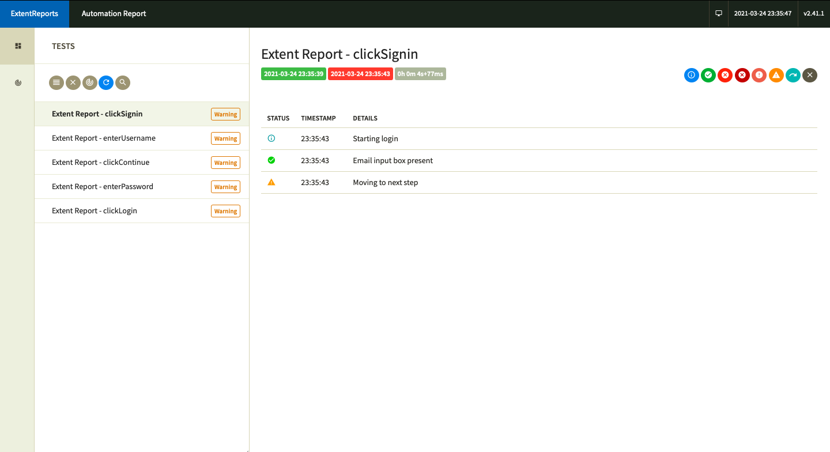

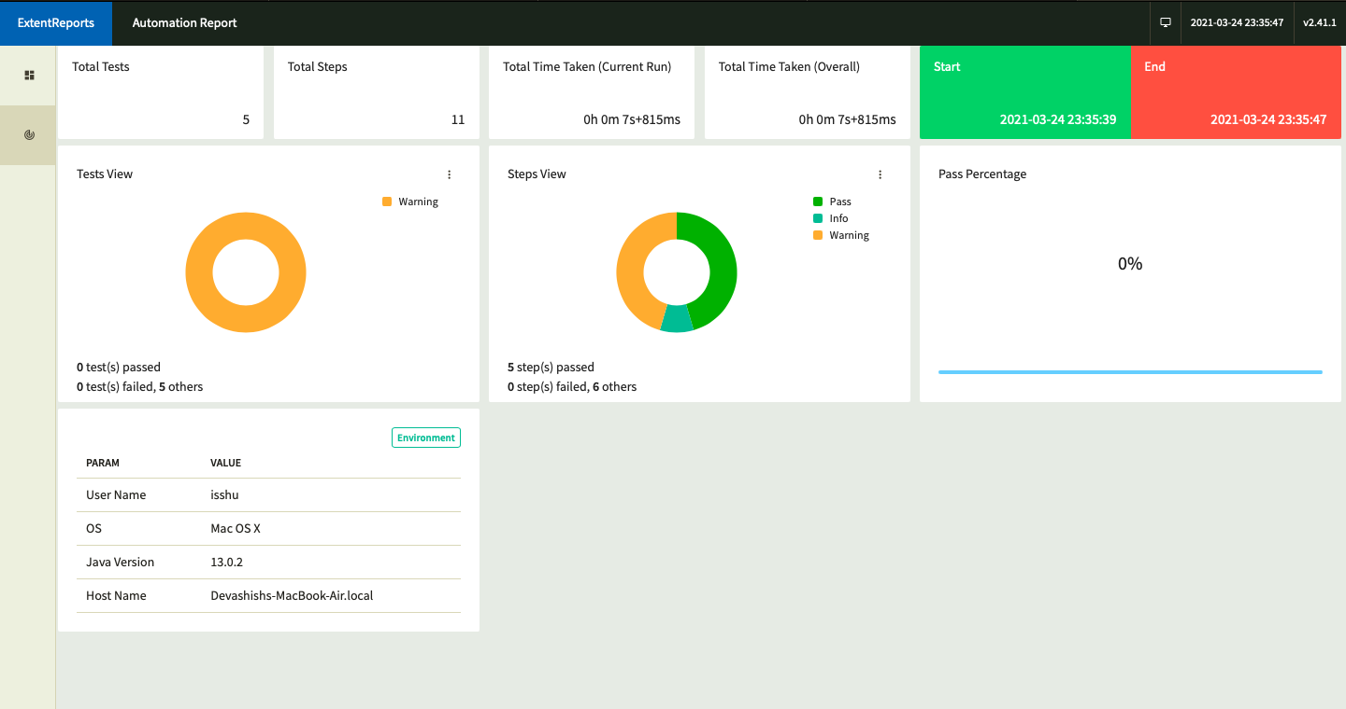

***Console Output:-***

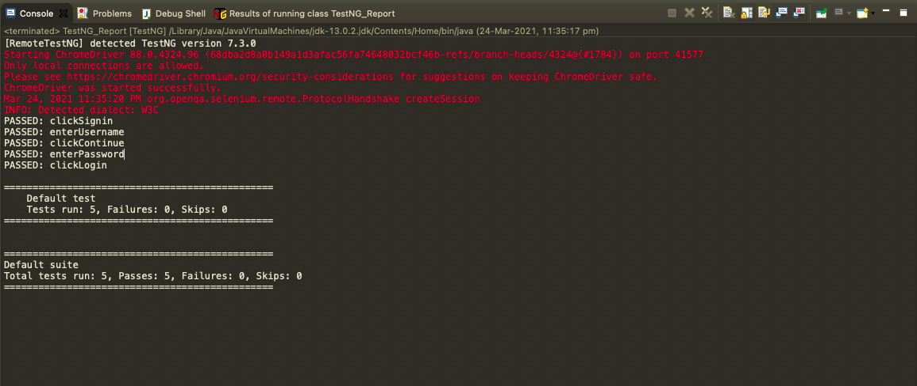

**EXPERIMENT-10**

***Title: Integrate Jenkins with TestNG suite and login to amazon.in***

**CODE**

import org.openqa.selenium.By;  
import org.openqa.selenium.WebDriver;  
import org.openqa.selenium.WebElement;  
import org.openqa.selenium.chrome.ChromeDriver;  
import org.testng.annotations.*;  
public class jenkins_test {  
  
 String base_URL = "https://www.amazon.in/";  
  
 WebDriver chromedriver;  
  
 @BeforeTest  
 public void launchBrowser() {  
 System.*setProperty*("webdriver.chrome.driver", "D:\\ChromeDriver\\chromedriver.exe");  
 chromedriver = new ChromeDriver();  
 chromedriver.get(base_URL);  
 chromedriver.manage().window().maximize();  
 }  
  
 @Test(priority=0)  
 public void findsignin() {  
 WebElement signin = chromedriver.findElement(By.*id*("nav-link-accountList-nav-line-1"));  
 signin.click();  
  
 }  
 @Test(priority=1)  
 public void enter_email() {  
 WebElement email = chromedriver.findElement(By.*id*("ap_email"));  
 email.sendKeys("3456gaurav@gmail.com");  
  
 }  
  
 @Test(priority=2)  
 public void click_continue() {  
 WebElement continu = chromedriver.findElement(By.*id*("continue"));  
 continu.click();  
 }  
  
 @Test(priority=3)  
 public void enter_pwd() {  
 WebElement pswd = chromedriver.findElement(By.*id*("ap_password"));  
 pswd.sendKeys("");  
  
 }  
  
 @Test(priority=4)  
 public void click_sigin() {  
 WebElement signin1 = chromedriver.findElement(By.*id*("signInSubmit"));  
 signin1.click();  
 }  
  
 @AfterTest  
 public void Quite() {  
 chromedriver.quit();  
 }  
}

**TestNG.xml file**

<?xml version="1.0" encoding="UTF-8"?>  
<!DOCTYPE suite SYSTEM "https://testng.org/testng-1.0.dtd">  
<suite name="Test Jenkins">  
 <test name="lab2">  
 <classes>  
 <class name="jenkins_test"/>  
 </classes>  
 </test> <!-- lab2 -->  
</suite> <!-- Default Suite -->

**OUTPUT**

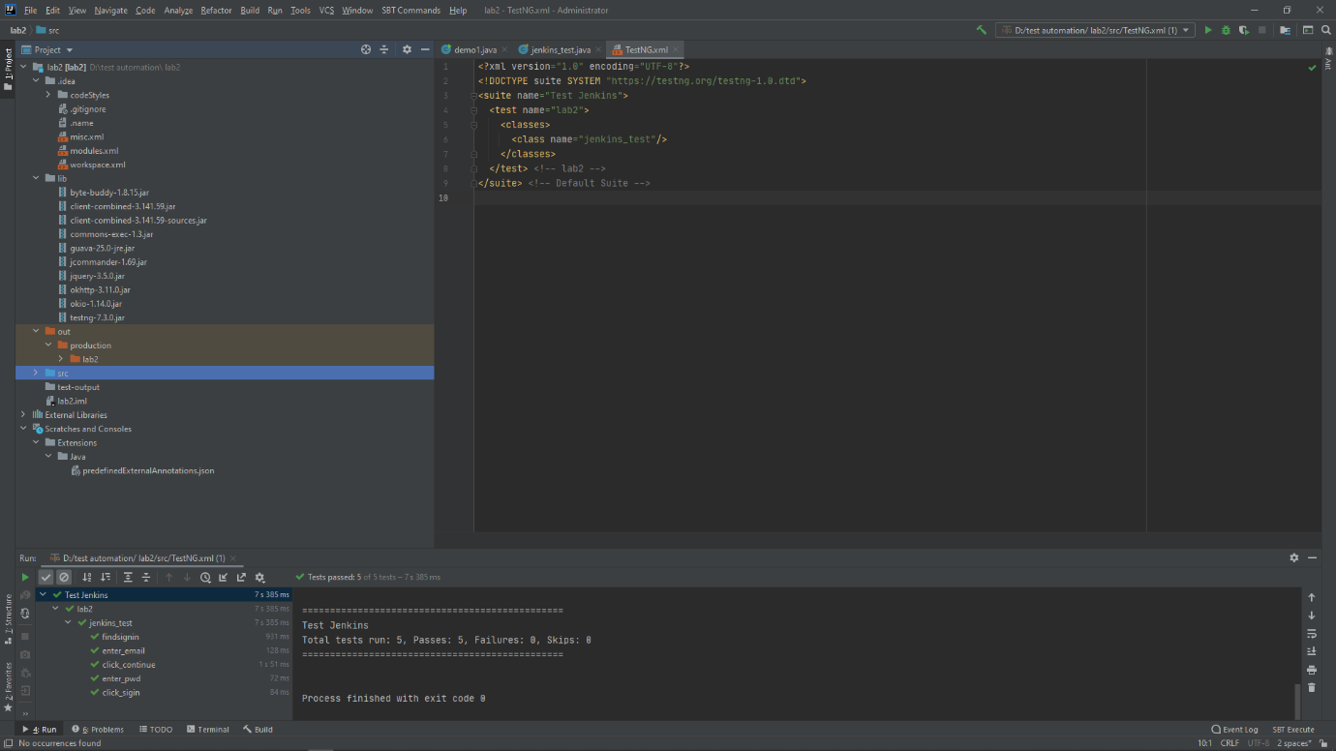

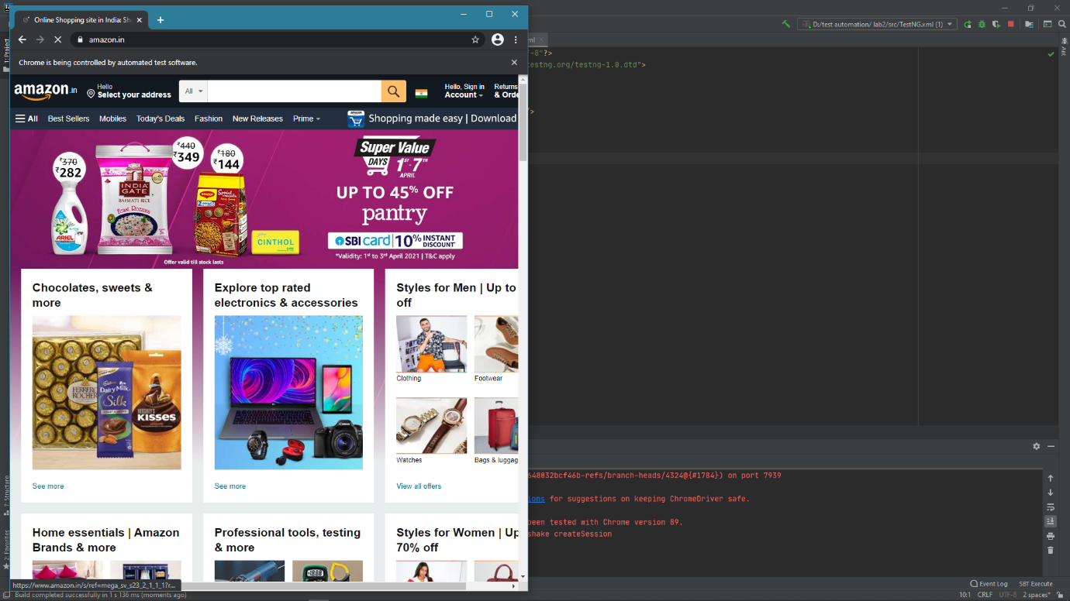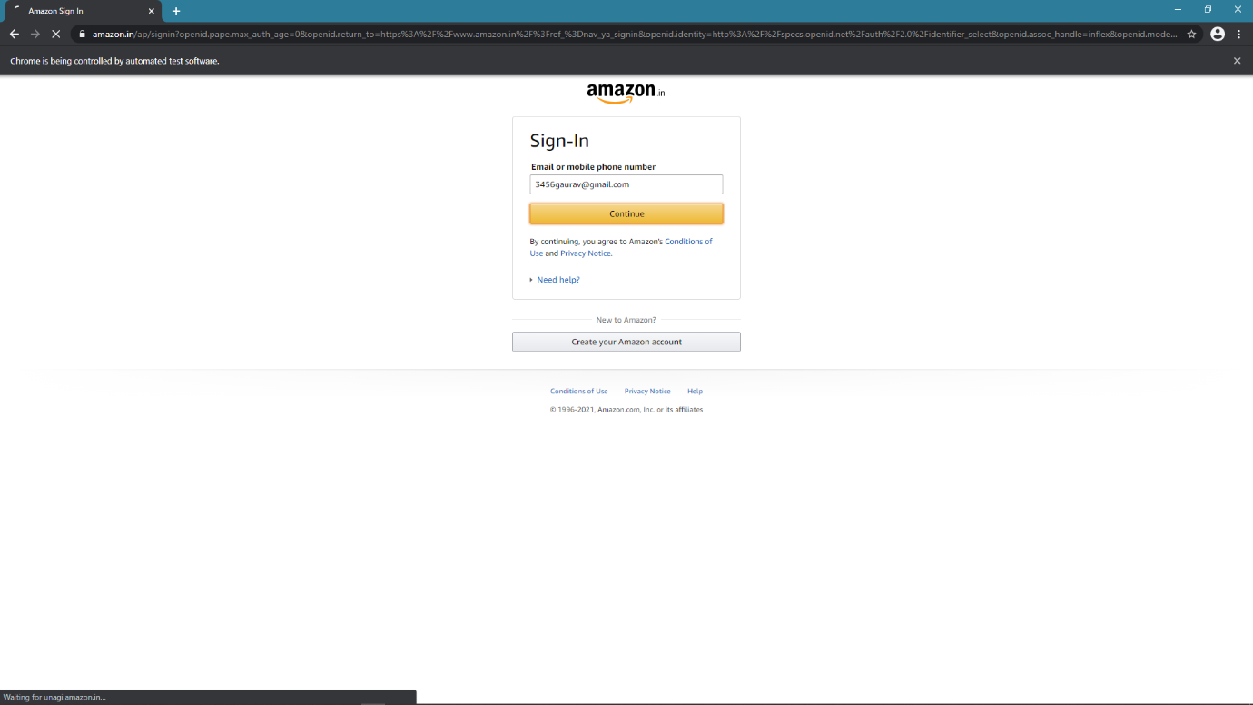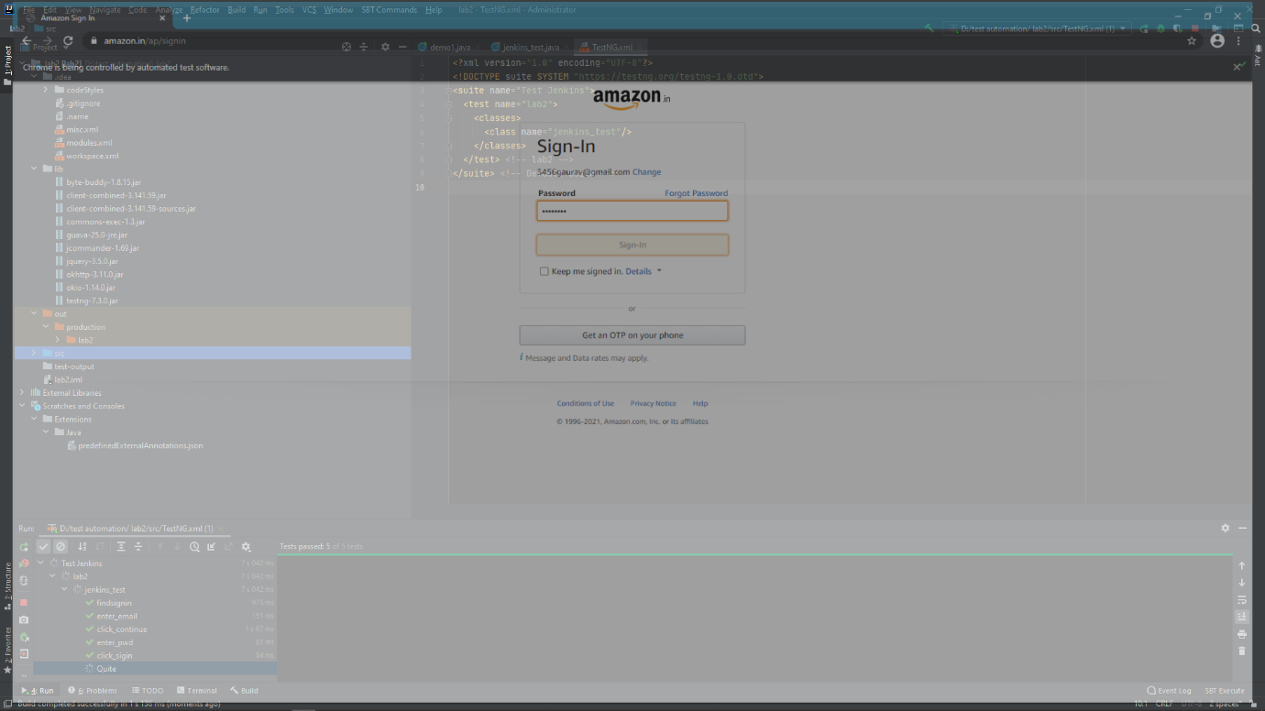

**OPEN JENKINS**

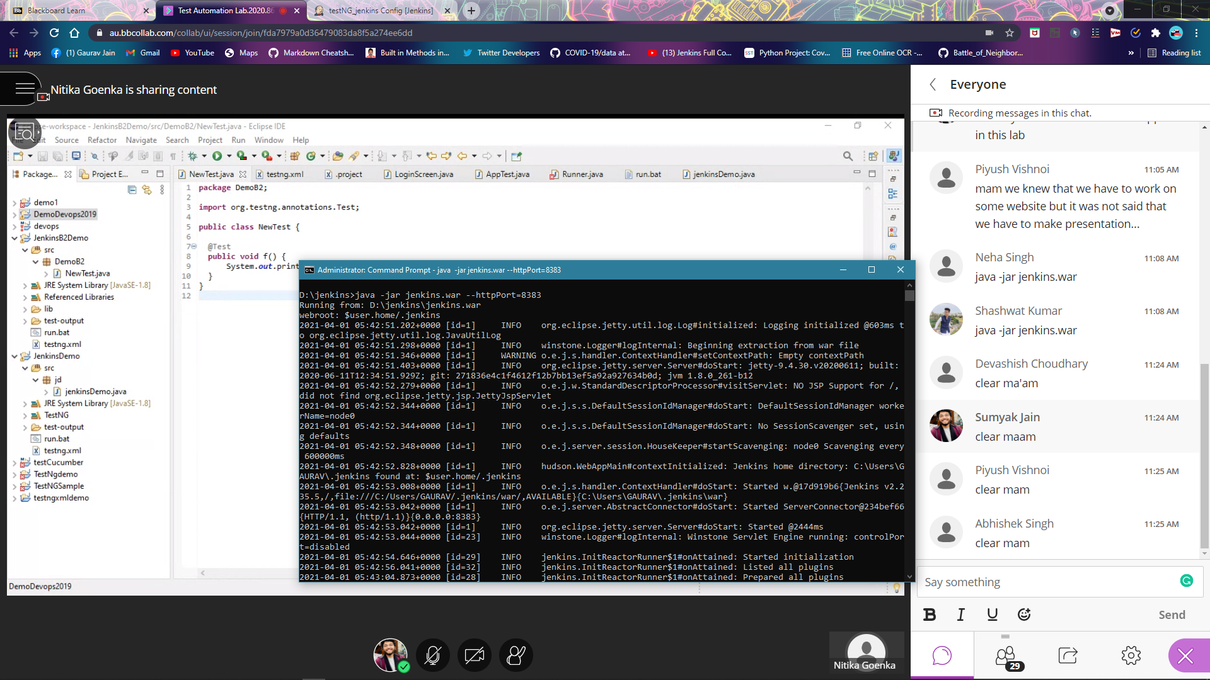

**CREATE A FREESTYLE PROJECT AND PROVIDE BUILD STEP**

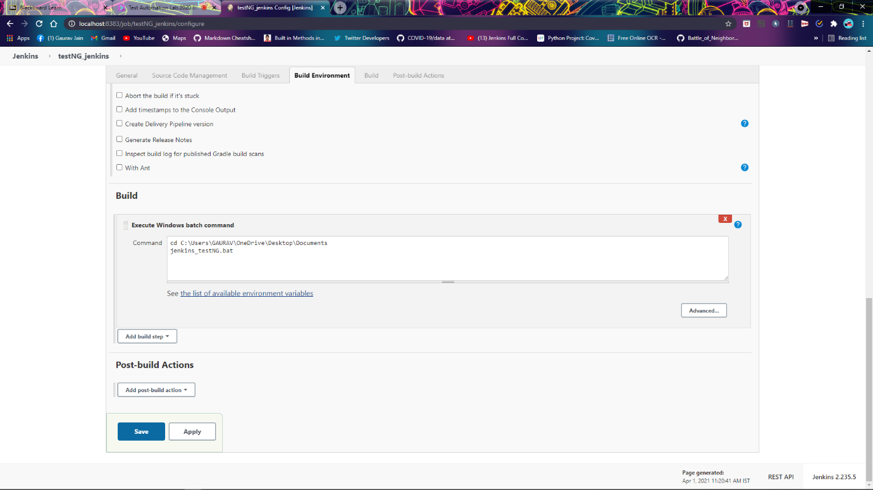

**BUILD OUTPUT**

